WORK IN PROGRESS

**Team 2**

**gocart.com**

**Team Members:**

**Abit Mahato**

**Apil Parajuli**

**Bibek Maharjan**

**Bibek Shah**

**Pratish Joshi**

**Table of Contents:**

01 Initiation Phase 1

Project Charter 4

Team Contract 8

02 Planning Phase 13

Belbin Analysis 13

Individual Belbin analysis 13

Team Belbin Analysis 13

Skill Audit 14

Individual Skill Audit 14

Team Skill Audit 14

MS Project 15

Gnatt Chart 15

Task Sheet 17

Resource Sheet 17

Calendar 18

Change Working Time 20

Timeline 21

Meeting Minutes 21

Communication Tools Used 22

Discord 22

Google Drive 22

Gmail………………. 23

03 Executing Phase 24

Entity Relationship Diagram 24

ERD 24

EERD 24

Composite ERD 25

Logical ERD 26

Use Case Diagram 27

Overview Use Case Diagram 27

Customer Use Case Diagram 28

Trader Use Case Diagram 29

Admin Use Case Diagram 30

Requirement Catalogue 31

MoSCoW Requirements 36

Website Logo 36

Wireframe 37

Customer wireframes 37

Management Wireframes 46

Trader Wireframes 49

# 01 Initiation Phase

## Project Charter

|  |
| --- |
| Project Title: goCart  Section : C  Group : 2  Project Manager: Rohit Raj Pandey  Sponsor: The British College Customer: Citizens of Cleckhuddersfax |

Version Control

|  |  |  |
| --- | --- | --- |
| Version | Date | Summary of changes |
| 1 | 05/02/2021 | Initial Project Plan |
|  |  |  |

Project Justification

|  |
| --- |
| ‘goCart’ is an e-commerce website that assures the availability of different local traders along with their products in a single platform. People nowadays find it difficult to manage their time, so ‘goCart’ can assist them in shopping for their necessities during their busy work schedule. With just a few multiple clicks, they will be able to shop during their busy work schedule from their local and trusted sellers with a fast, safe, and convenient method.  ‘goCart ’will be equipped with a web interface where traders can manage their shop and product information with their login credentials through the portal. All items will have a unique ID that will be affiliated with a trader which will be consisting of a short name, description, an item price, quantity per item, stock available, minimum order, and maximum order. Traders can also access the database regularly to view reports on orders, stock levels, and other details. Traders will be provided with a unique username that only gives them access to their respective account information and to update it as per their need. Any of the trader's accounts can be accessed via admin login.  Customers will be able to browse items by product type or shop as they prefer. All the products will have their unique id and trader’s name, so it will be easy for the customers who would like to make their purchase from a particular trader. Customers will also have something new to experience as they will be shifting from old traditional ways of shopping to online shopping where customer’s goods are delivered to the provided addresses instead. ‘goCart’ will be viewable on all types of devices ranging from computers, laptops to mobile phones and tabs. Customers can add different products from different traders in a single cart and make their payments as a whole. Before placing an order, users must be registered into the system. Users who are registered will have access to place an order, account information and will be able to check and update it as per their desire. Registration and account changes should ideally be verified through email contact. If users are not registered in our system, they will be unable to access their order cart. Hence, making them unable to proceed with further procedures. At last, we will be using PayPal as our primary way to make payments which will help customers to pay online.  Customer's and trader's working hours tally most of the time. Traders cannot increase opening hours  without losing out on family life and it is hard for customers to go to the market to buy their stuff after a long and tense day. So, for the betterment of the customers along with the traders ‘goCart ’intends to save their valuable time so that they can use it somewhere fruitful. Customers need not visit different shops physically as they will be exploring all the products and purchasing them online. With just some clicks, they will be saving their time along with avoiding the crowds. Traders will also have great relief from checking the stock levels frequently in their stores as comparing to the automatically generated reports via the website. Traders will not have a limited opening hour which will smoothly grow their business. |

**Project Scope**

|  |
| --- |
| SMART GOALS  Major Objectives:   * To create an e-commerce website that includes several local stores of Cleckhuddersfax having distinct product lines. By exposing our website to audiences of different age groups, our website will gradually increase trader’s profit by having a huge amount of sales with a reduced amount of effort, saving time. * Trader Interface Benefit   + Traders can manage their products and information on their shops using their respective trader’s account.  + Traders can view reports on multiple categories.   * Management Interface Benefit   + Traders will be provided with daily, weekly, monthly reports via Dashboard on different categories.   * User-Friendly Website for Customer’s and Trader’s   +Attracts more audiences  +More Revenue   * Data and Transaction   + Analysis and Evaluation of the Report and Record  Time:  Start Date: 05/02/2021  Work in Progress: 06/09/2021  End Date: 07/02/2021 |

|  |
| --- |
| Customer Interface:   * Responsive website consisting of simple navigation features. * Product lines and products are unique within the traders. * Registration and login system for customers. * Customers must be registered to buy the products. * Cart function to place the order for logged-in users. * Customers can review and update their account details. * Customers can collect their products in a different timeline. * Payment through the credit card system to be considered, including PayPal.   Trader Interface:  - An admin login system to access trader’s account  -A proper web interface to manage products and view reports  -An admin login that can access any of the trader accounts / whole systems  Management Interface:   * A management dashboard for traders to access daily and periodic reports. * Traders will be able to run the report on the orders placed for their goods. * Reports can be organized using several formats. |

**Duration**

|  |
| --- |
| Start Date: 05/02/2021 Work in Progress: 06/09/2021  Final Presentation: 07/02/2021  Team Portfolio: 07/12/2021 |

**Estimated Budget**

|  |  |  |  |
| --- | --- | --- | --- |
| Name | Working Day | Working Hour | Total Working Hour |
| Pratish Joshi | 4 | 10 | (10 hour *10 weeks)=100 |
| Bibek Maharjan | 4 | 9 | (9 hour *10 weeks)= 90 |
| Apil Parajuli | 4 | 9 | (9 hour *10 weeks) = 90 |
| Abit Mahato | 4 | 9 | (9 hour * 10 weeks) = 90 |
| Bibek Shah | 4 | 9 | (9 hour * 10 weeks) = 90 |

**Roles and Responsibilities**

|  |  |
| --- | --- |
| Name | Role |
| Pratish Joshi | Primary Role (Co-ordinator), Secondary Role (Specialist), Least Likely Role (Completer Finisher) |
| Bibek Maharjan | Primary Role (Resource Investigator), Secondary Role (Plant), Least Likely Role(Completer Finisher) |
| Apil Parajuli | Primary Role (Shaper), Secondary Role (Implementer), Least Likely Role(Monitor Evaluator) |
| Abit Mahato | Primary Role (Monitor Evaluator), Secondary Role (Completer Finisher), Least Likely Role (Specialist) |
| Bibek Shah | Primary Role (Team Worker), Secondary Role (Plant), Least Likely Role (Co-ordinator) |

## Team Contract

This is a team contract of Group 5 to develop an e-commerce prototype website. This team contract is used to ensure that the team members will be held accountable for any consequences, setbacks or mistakes. This contract also shows how the team functions and what sort of actions the team will take in securing the completion of the project.

Project Team Name: goCart

Project Team Name: goCart

|  |  |  |  |
| --- | --- | --- | --- |
|  | Team Member Name | Email | Phone |
| 1 | Pratish Joshi | joshipratish997@gmail.com | 9860802472 |
| 2 | Bibek Maharjan | bibekmaharjan65@gmail.com | 9860722698 |
| 3 | Apil Parajuli | parajuliapil7@gmail.com | 9861331622 |
| 4 | Abit Mahato | abitmahato712@gmail.com | 9808079576 |
| 5 | Bibek Shah | shahbibek17@gmail.com | 9810473791 |

A. Team Structure:

1. Leadership structure:

- Team leadership will be handled by a particular individual throughout the project so that we can have single individual who can make logical decisions that can be worked throughout the whole project.

- Pratish Joshi will be responsible for the proper leadership of the team because of his ability to take charge and properly lead the team.

2. Decision-making policy:

- The decisions will be made primarily using consensus.

- If every team member cannot agree on a particular topic a voting system will take place.

3. Who is the team Recorder/Documentation Manager/Maintainer of team activity?

- The person responsible for recording, managing the documentation and maintaining team activities will be done by Pratish Joshi.

4. Day, time, and place for regular team meetings:

- There will be formal meetings 3 days a week.

- We will be holding team meetings on Wednesday 4:30pm - 6:00pm, Thursday 4:30pm - 6:00pm and Friday 4:30pm - 6:00pm.

- Meetings and Daily Discussions will take place in Discord.

- Link: <https://discord.gg/FbjjtnDeFk>

5. Usual method of communication:

- Discord will be used as the usual method of communication.

- Google Drive will be used to share documents and files.

B. Team Procedures:

1. Method for setting and following meeting agendas:

- The meeting agendas will be set by our team leader.

- Team leader will be taking full responsibility and making sure that the team is following the meeting agendas during the team meeting.

- All the team members will be notified about the team meeting ahead of the time using Gmail and Discord.

2. Method of record keeping:

- Recording and Spreading of the information will be assigned to Pratish Joshi.

- All the Agendas and Actions will be distributed through Google Drive, Discord that are accessible by every team member.

3. Procedures in the absence of a team member:

- The team meeting will not commence if two or more team members are absent. Hence, the meeting will be postponed until further notice.

C. Team Participation:

6. Strategies to ensure cooperation and equal distribution of tasks:

- Team members will get the chance to select the tasks they would like to perform in an allocated time.

- Team members can help each other if they get any issues while performing their tasks and can help other members if someone finishes their tasks before deadlines.

- Members will be asked to provide a rough weekly report.

7. Strategies for encouraging/including ideas from all team members:

- Every team member can share their ideas and opinions in the meetings and can raise voice if they have any confusion.

- Decisions will be taken in the favor of all team members either by consensus or voting.

8. Strategies for keeping on task:

- The team leader will check the work done by everyone at the end of the week.

- In every meeting, deadline of the tasks will be reminded.

D. Personal Accountability:

1. Expected individual attendance, punctuality, and participation at all team meetings:

- Team members should have at least 80% of attendance.

- Interruption is only allowed after the member who is speaking finished his/her statement so that every member will be able to share his/her views.

- Team members will be penalized if any members are to join the meeting late.

- Every team member should actively participate in each and every meeting.

2. Expected level of responsibility for fulfilling team assignments, timelines, and deadlines:

- We will have our initial deadline two weeks before the actual deadline so that we can finish our assignments prior to the final deadline.

- Every member from the team is expected to guide and help each other if required.

- Every member should finish their assigned task within the given time period.

3. Expected level of communication with other team members:

- If any member faces difficulties while doing the task then he/she can ask for the help from other team members.

- If there is any urgent concern then every member from the group should be notified.

- Team members are expected to communicate with each other via discord.

- Team meetings will be conducted on the discord server and every member should join the meeting room, ten minutes prior to issued meeting time.

4. Expected level of commitment to team decisions and tasks.

- Team decision will be only finalized after every member from the team agrees to the decision. Each member will commit equally to the team’s decision so that none of the team members are given more importance than other.

- If contribution of any member is not seen or violates the contract then after week 6, that member will not be contributing to the project anymore.

E. Consequences of breach of contract:

Consequences will be based upon how a team or a certain individual performs. In order to ensure the proper work by honoring the contract, everybody's full commitment is a must. For every consequence a strike program is implemented for maintaining a consistent and proper flow of the work.

Due to various reasons strikes may be given:

- Low commitment, misconduct or dishonest work presented during assigned tasks.

- Not attending meetings, not performing the task on given time without notifying the team members or the instructor.

F. Certification by team members:

In appending your signatures below, you are stating that:

a) You participated in formulating the standards, roles, and procedures of this contract.

b) You have agreed to abide by these terms and conditions of this contract.

c) You understand that you will be subject to the consequences specified above and may be subject to reduction in overall grade in the event that you do not fulfil the terms of this contract.

|  |  |  |  |
| --- | --- | --- | --- |
| Name | Pratish Joshi |  |  |
| Signature | https://lh3.googleusercontent.com/gjjs1zC5FNaVFaIXiwDay0Ptifvk_zqpxD9Wb-oUQnqz1o4h5ZdS3rtwK3iNFnWLq2aDYJB2aH_GBMiNZgVQ84qidzsm7YcovFM3fpxCKTBef2Ev1U8TBdBBjKDbBKiBu7IRm-rR | Date | 05/05/2021 |
| Name | Bibek Maharjan |  |  |
| Signature | https://lh4.googleusercontent.com/ljqRsfAfWymLlh4bvmqKHw9Ar6UMD1LJnpdN9X8qh6kVFPgrni2HhJBst8EhItaiEO9z8snj6-FL4Q9NyHqh_dohRVTo4A3St-qBm6ezzkK5WjLr0N8RIbUYj-fkHG9tXP4wPW7H | Date | 05/05/2021 |
| Name | Apil Parajuli |  | |
| Signature | https://lh6.googleusercontent.com/ZHaCN9ZcTizUMa3T_O8f8sYKAdMtLvuPmYtF3dHerKyWNwLVde-F5jdmbZ0WTx6XRA0e7d2HHxZadOoD2iBFgzXqNdwyMWDABrqAeoMPh-rhTKbXiUG_VKxURXn-qhE42AYpeO_N | Date | 05/05/2021 |
| Name | Abit Mahato |  |  |
| Signature | https://lh3.googleusercontent.com/mOTKHgB-it-7iwK49c4Gr5yQNCU5kX4KuyO71E6FzsQanfoHfufFGe9GO-fqdxqmQvzRsJzlK1juVGSVKhgYd5gnMILrKewI3ioBON2bz0UPl5qb93XrYrFQR_QjhvT9ZVucDK5r | Date | 05/05/2021 |
| Name | Bibek Shah |  |  |
| Signature | https://lh3.googleusercontent.com/mzQ2IBQ4kai8-Ohsat-Jup9yzQnDM6P_ASyCPZq62DWcmc7bkRkgQXNDwzdReZwBn0ff7AB250uOfHx0rj_jYJ7E6coQY4zIo03yaxt3TC2R1ec5EAFjKxJ6zuy8V_hcwURPMH0h | Date | 05/05/2021 |

G. Acceptance of contract by tutor:

|  |  |  |  |
| --- | --- | --- | --- |
| Name | Rohit Raj Pandey | Date |  |
| Signature |  |

# 02 Planning Phase

## Belbin Analysis

### Individual Belbin Analysis

|  |  |
| --- | --- |
| Name | Role |
| Apil Parajuli | Primary Role (Shaper), Secondary Role (Implementer), Least Likely Role(Monitor Evaluator) |

### 

### Team Belbin Analysis

|  |  |
| --- | --- |
| Name | Role |
| Pratish Joshi | Primary Role (Co-ordinator), Secondary Role (Specialist), Least Likely Role (Completer Finisher) |
| Bibek Maharjan | Primary Role (Resource Investigator), Secondary Role (Plant), Least Likely Role(Completer Finisher) |
| Apil Parajuli | Primary Role (Shaper), Secondary Role (Implementer), Least Likely Role(Monitor Evaluator) |
| Abit Mahato | Primary Role (Monitor Evaluator), Secondary Role (Completer Finisher), Least Likely Role (Specialist) |
| Bibek Shah | Primary Role (Team Worker), Secondary Role (Plant), Least Likely Role (Co-ordinator) |

## Skill Audit

### Individual Skill Audit

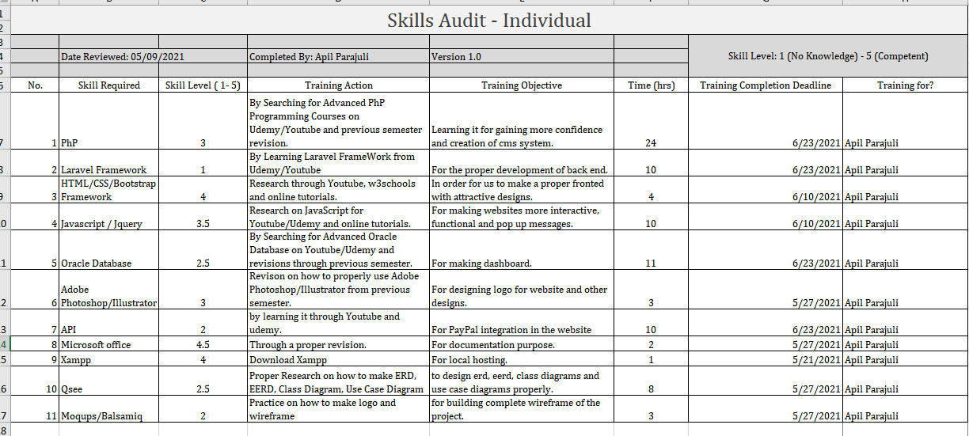

### Team Skill Audit

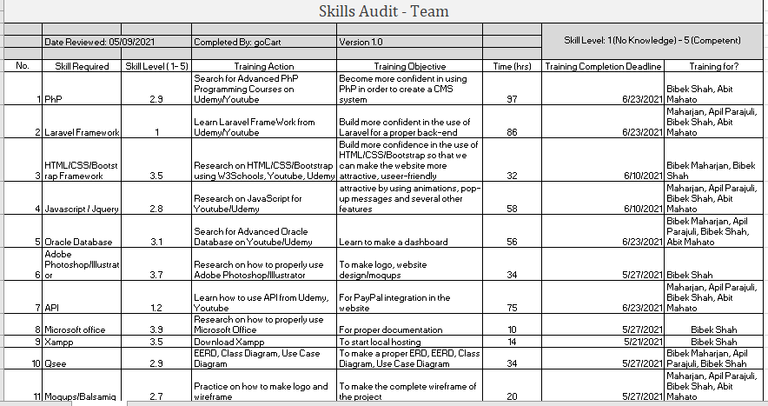

## MS Project

### Gnatt Chart

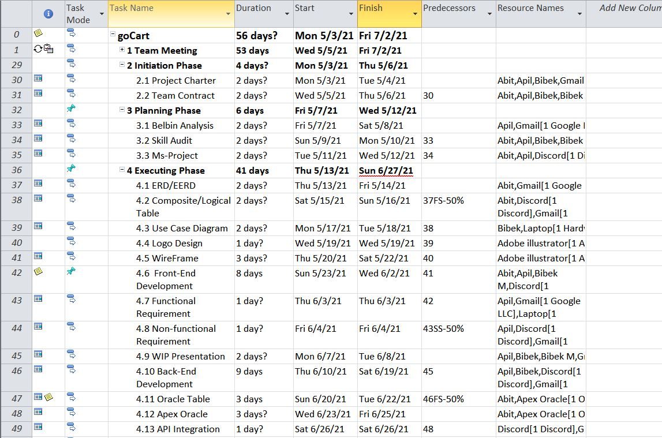

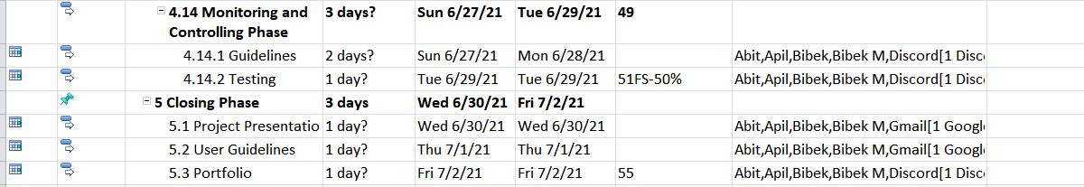

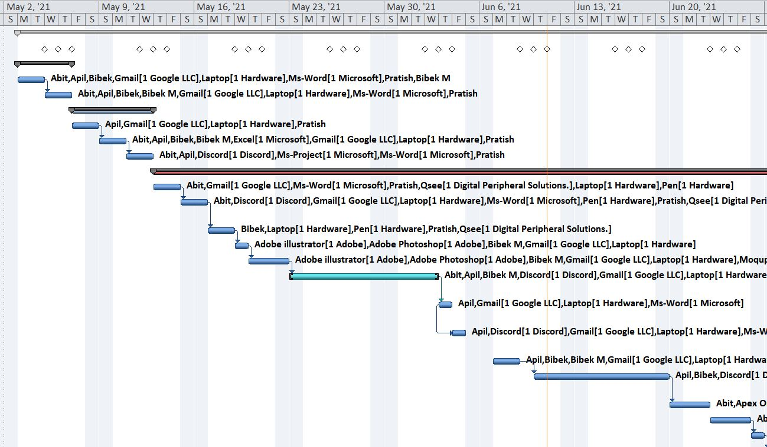

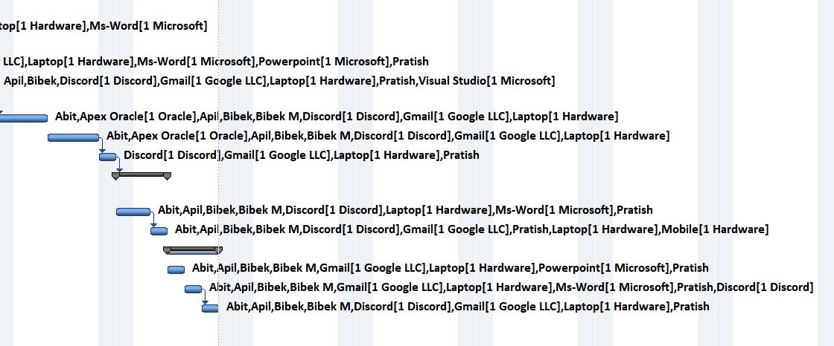

### Task Sheet

### Resource Sheet

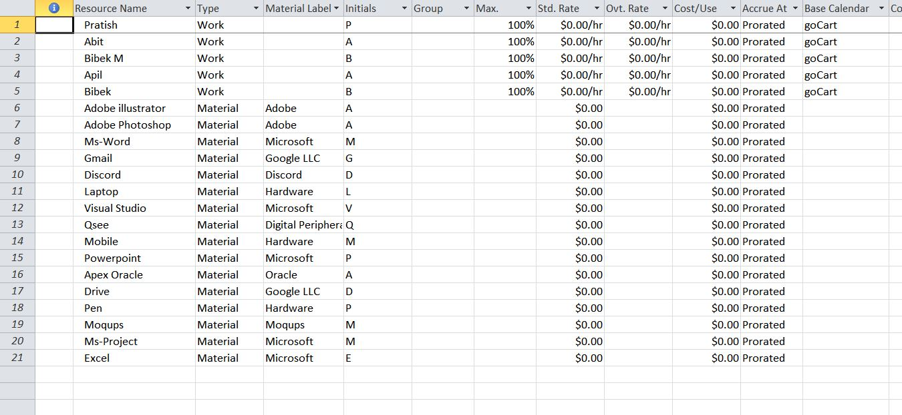

### Calendar

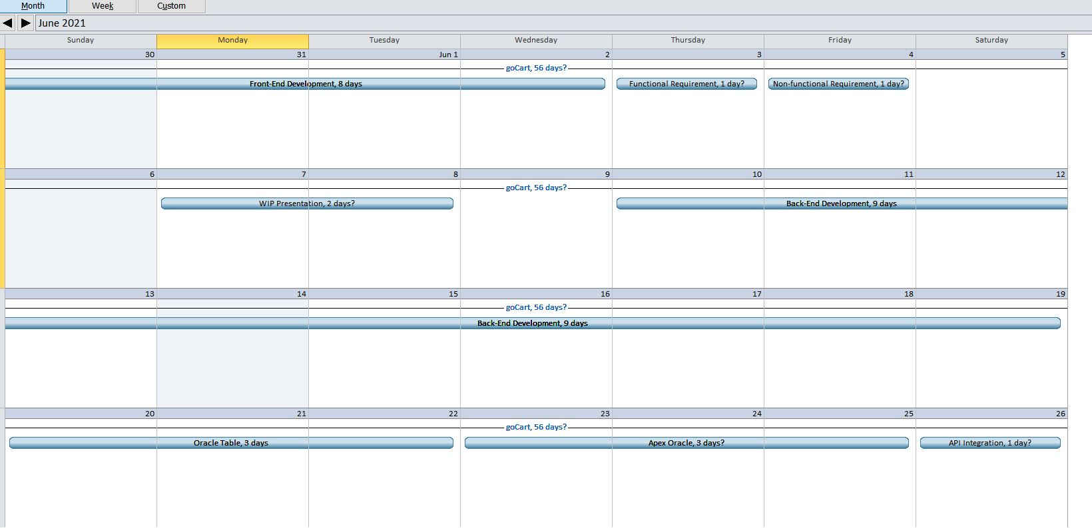

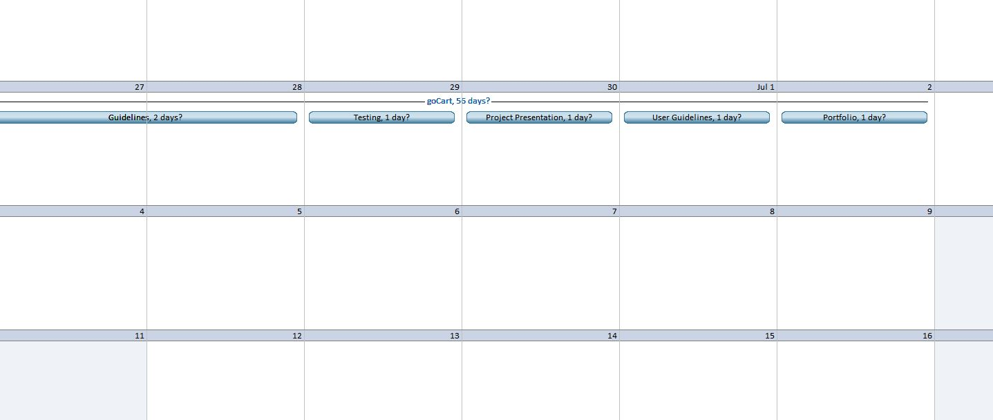

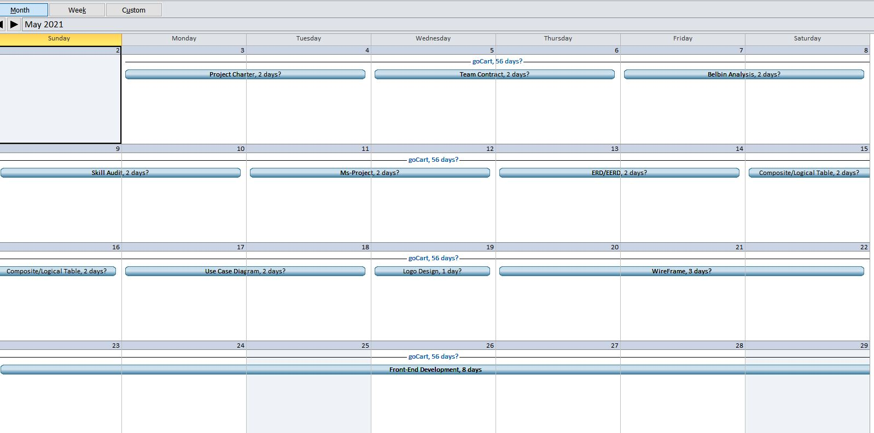

### Change Working Time

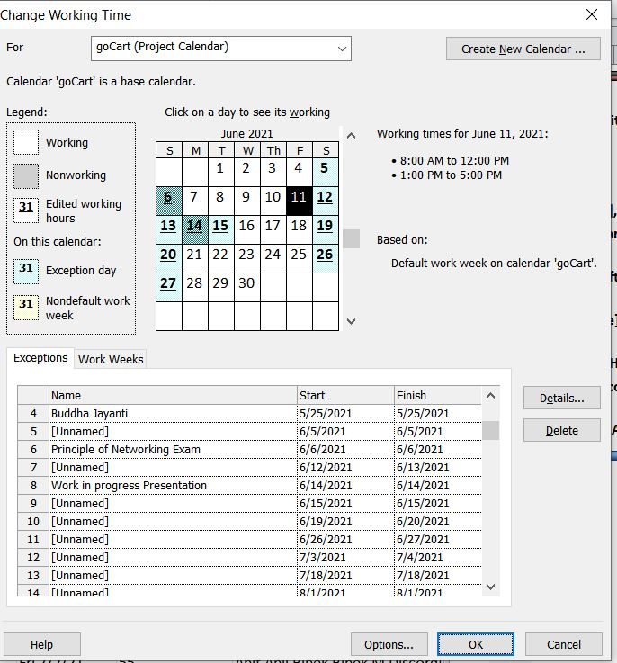

### Timeline

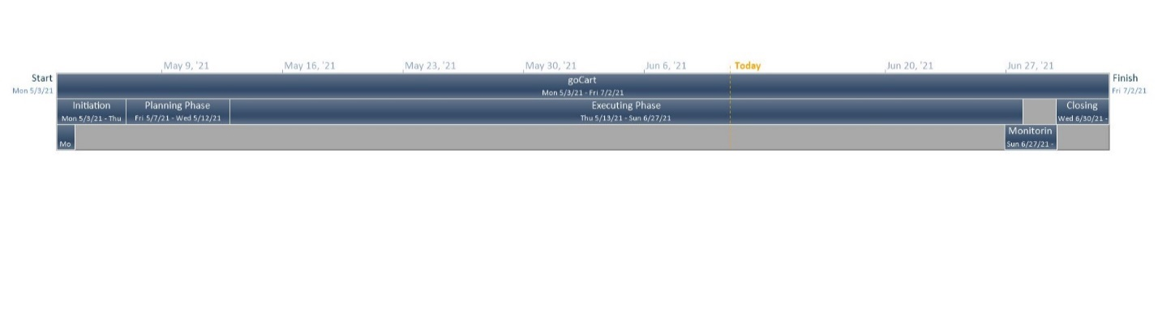

## Meeting Minutes

|  |  |  |  |  |
| --- | --- | --- | --- | --- |
| S. N | Members Present | Meeting Agenda | Location | Duration(minutes) |
| 1 | Pratish Joshi, Bibek Maharjan, Bibek Shah,Abit Mahato , Apil Parajuli | Case study. | Discord | 52 |
| 2 | Pratish Joshi, Bibek Maharjan, Bibek Shah,Abit Mahato , Apil Parajuli | Organizing and distributing the roles between the team members. | Discord |  |
| 3 | Pratish Joshi, Bibek Maharjan, Bibek Shah,Abit Mahato , Apil Parajuli | Project Charter, Team Contract. | Discord | 59 |
| 4 | Pratish Joshi, Bibek Maharjan, Bibek Shah,Abit Mahato , Apil Parajuli | Skill Audit, Belbin Analysis and MS project. | Discord | 60 |
| 5 | Pratish Joshi, Bibek Maharjan, Bibek Shah,Abit Mahato , Apil Parajuli | MoSCoW, EERD, ERD, composite ERD. | Discord | 67 |
| 6 | Avin Amatya, Lakash Maharjan, Rabindra Jaiswal, Rubin Shrestha, Youbaraj Nepal | Use Case diagrams and Work In Progress. | Discord | 61 |
| 7 | Avin Amatya, Lakash Maharjan, Rabindra Jaiswal, Rubin Shrestha, Youbaraj Nepal | Work In Progress, logo, wireframe | Discord | 60 |

## Communication Tools Used

**Discord:** 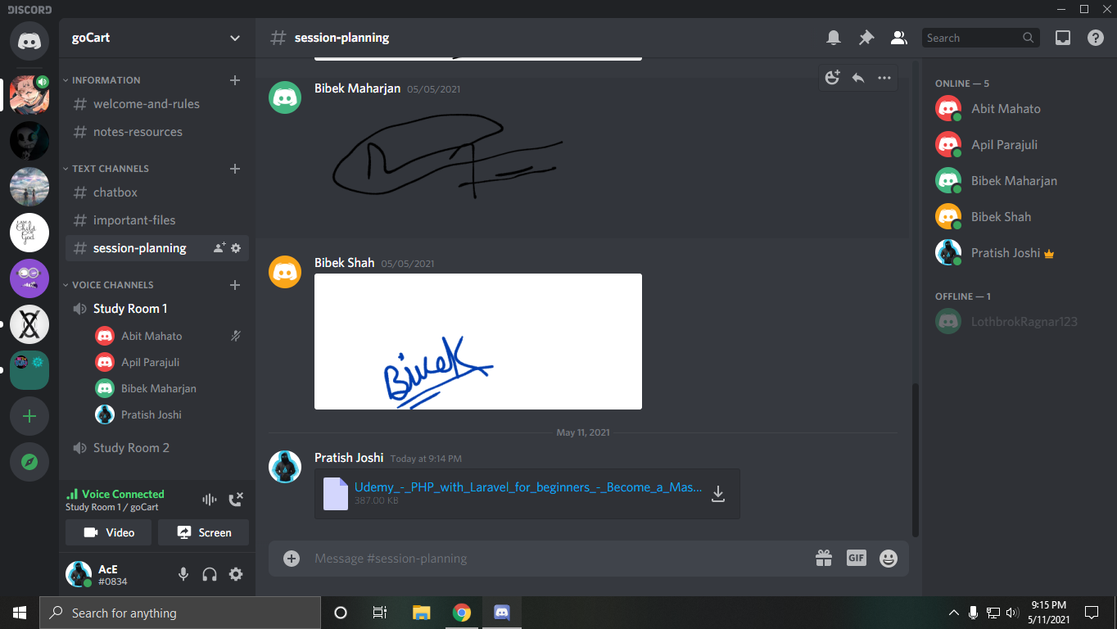

**Google Drive:**

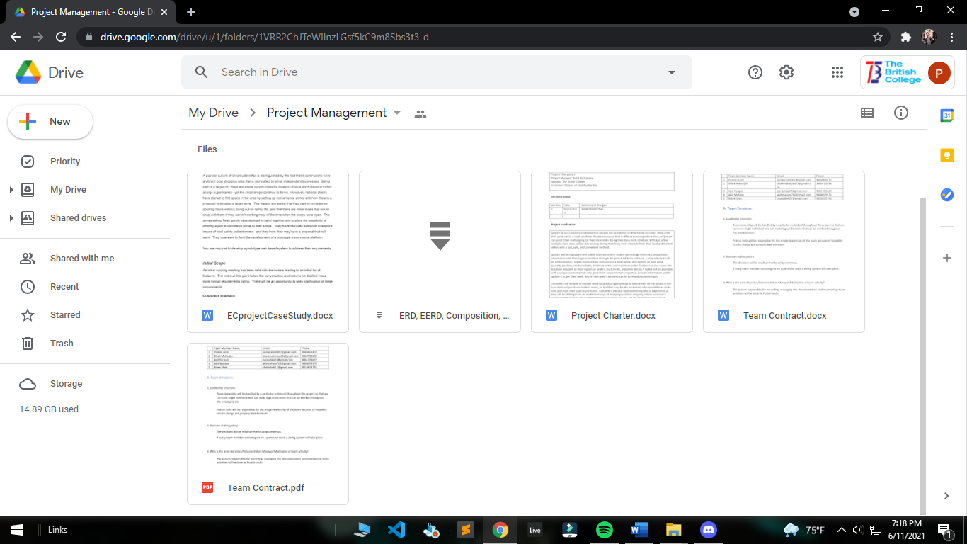

**Gmail:**

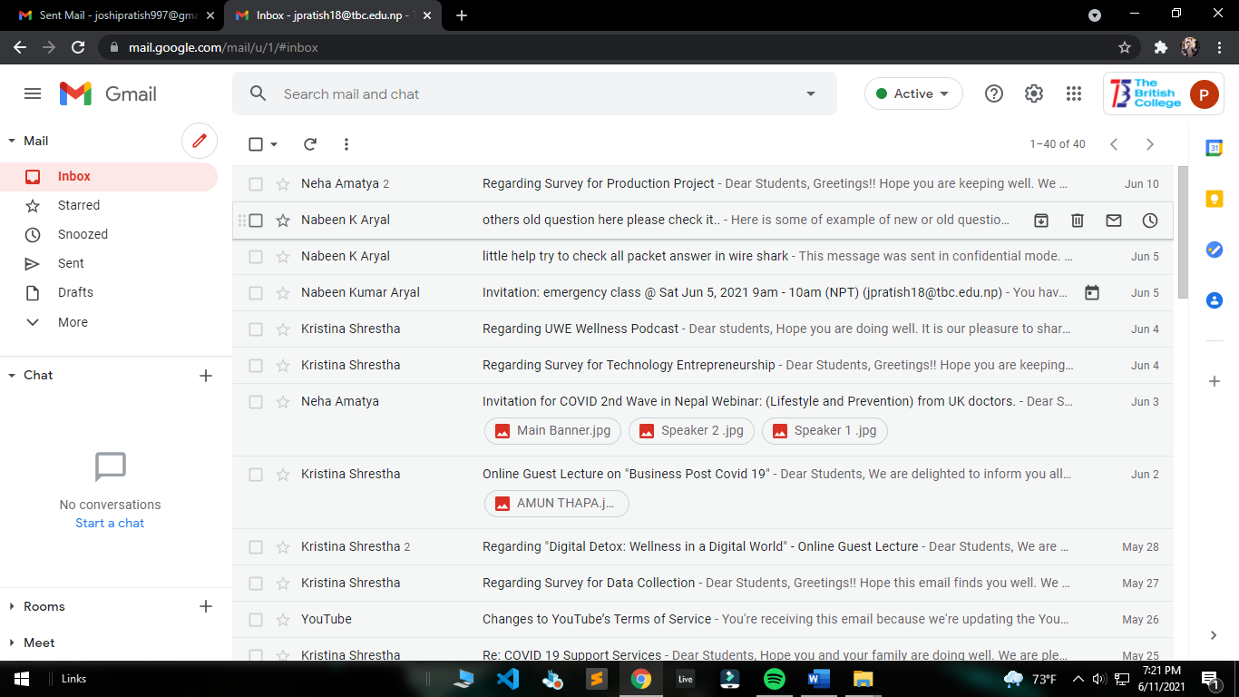

# 03 Executing Phase

## Entity Relationship Diagram

**ERD**

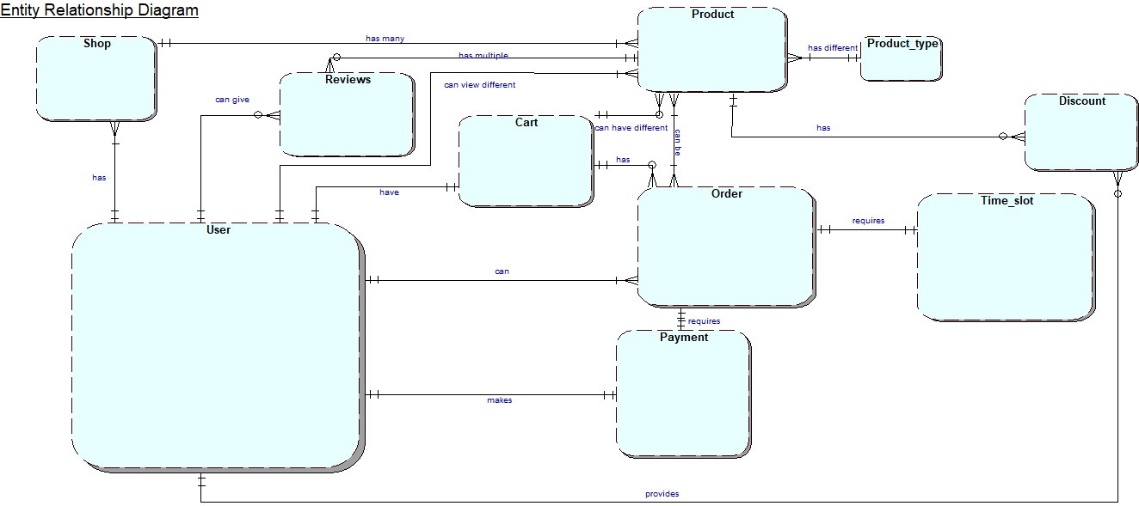

**EERD**

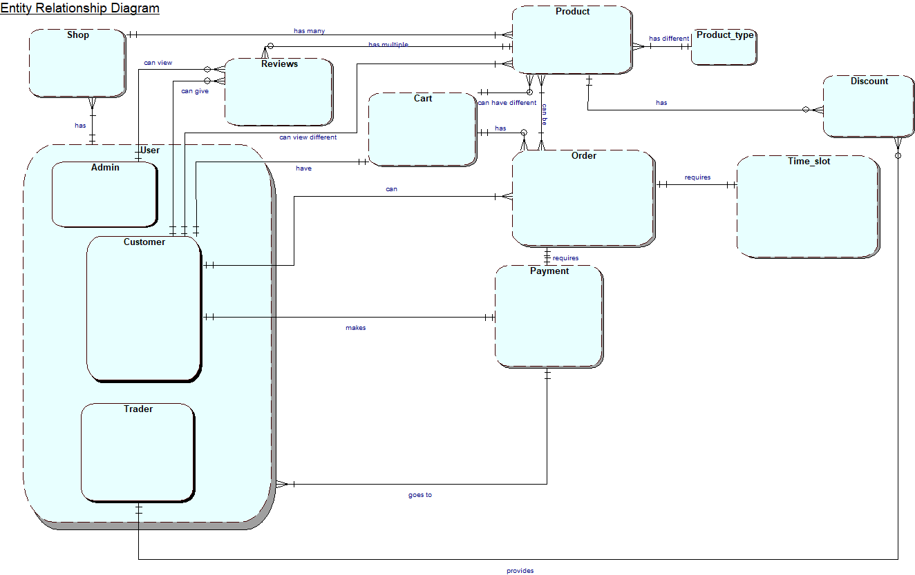

**Composite ERD**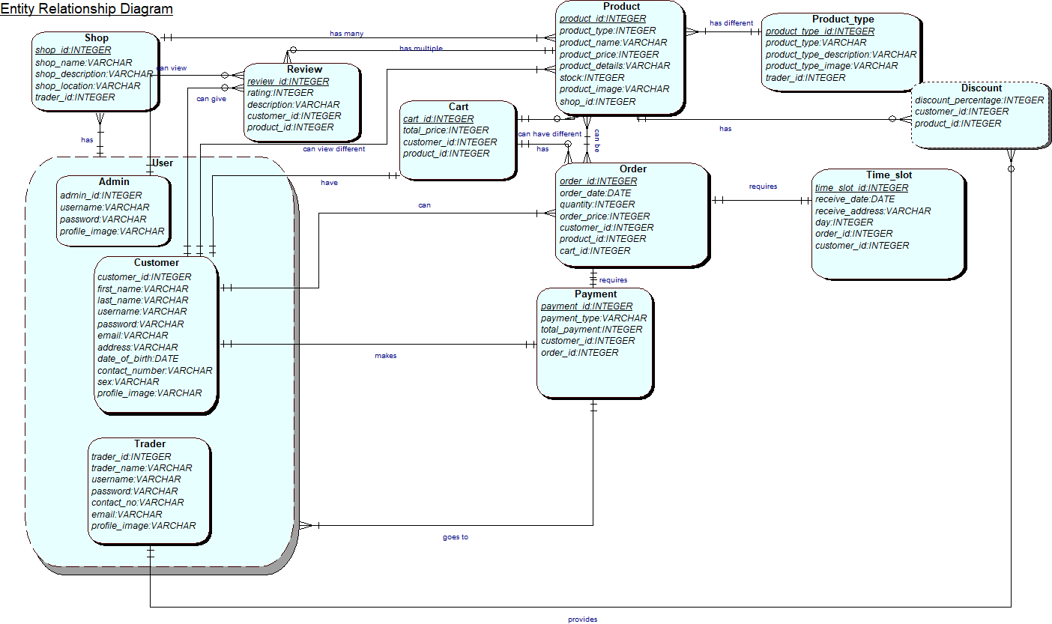

**Logical ERD**

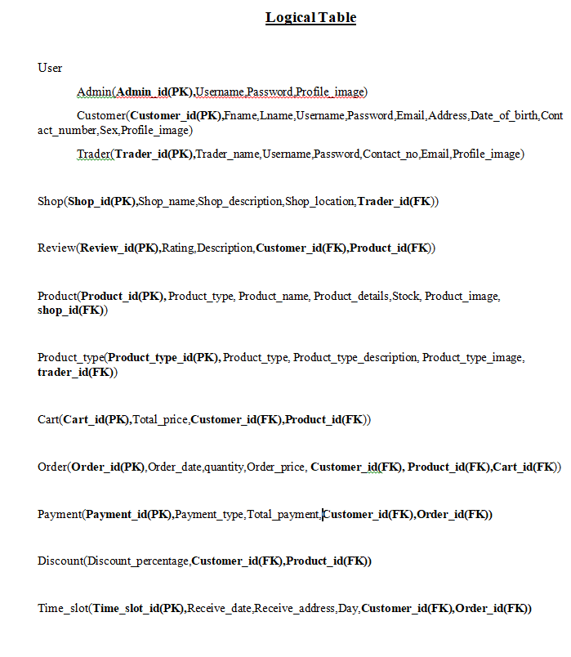

## Use Case Diagram

### Overview Use Case Diagram

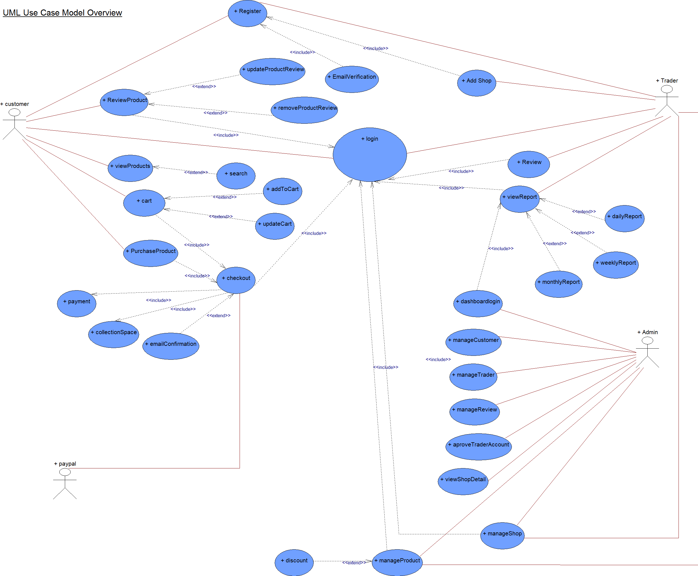

### Customer Use Case Diagram

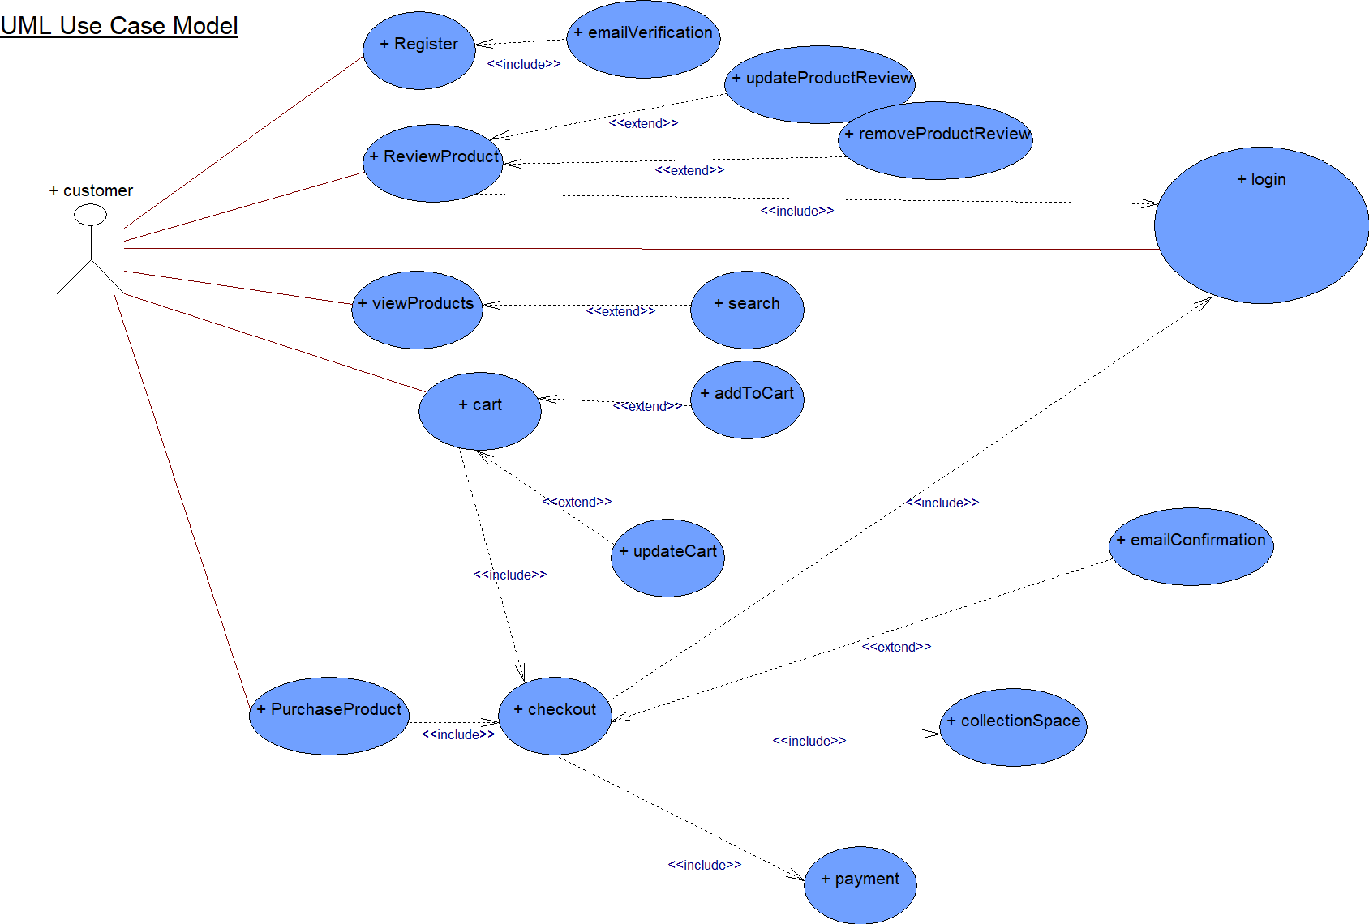

### Trader Use Case Diagram

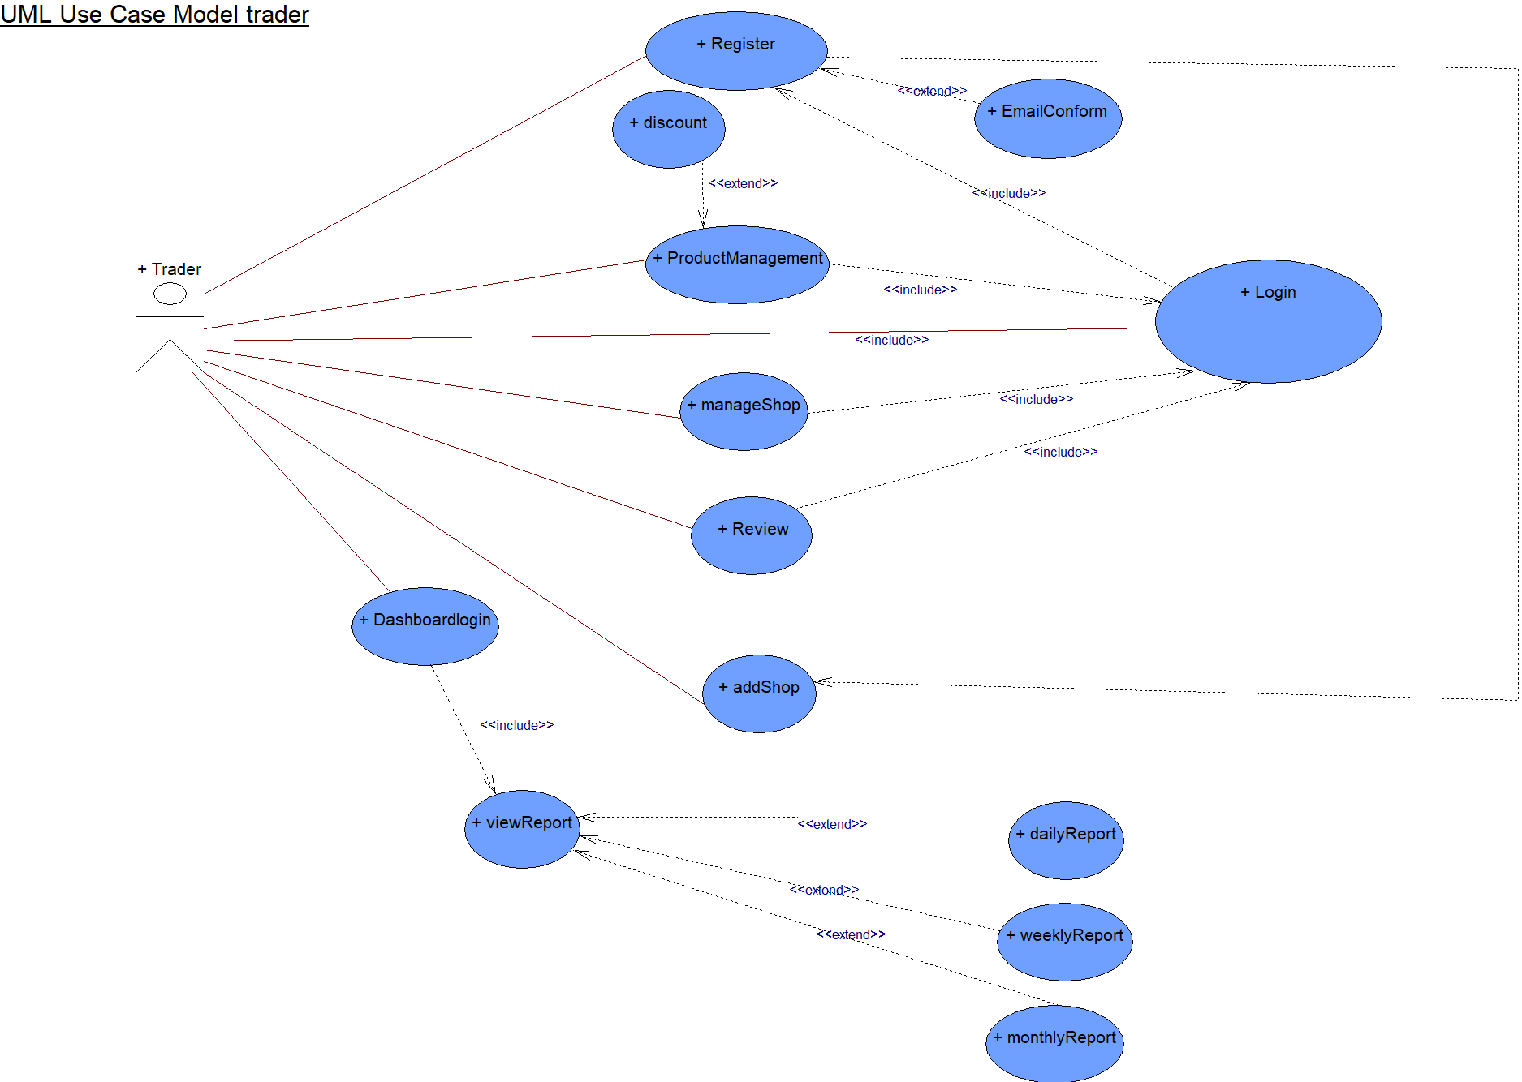

### Admin Use Case Diagram

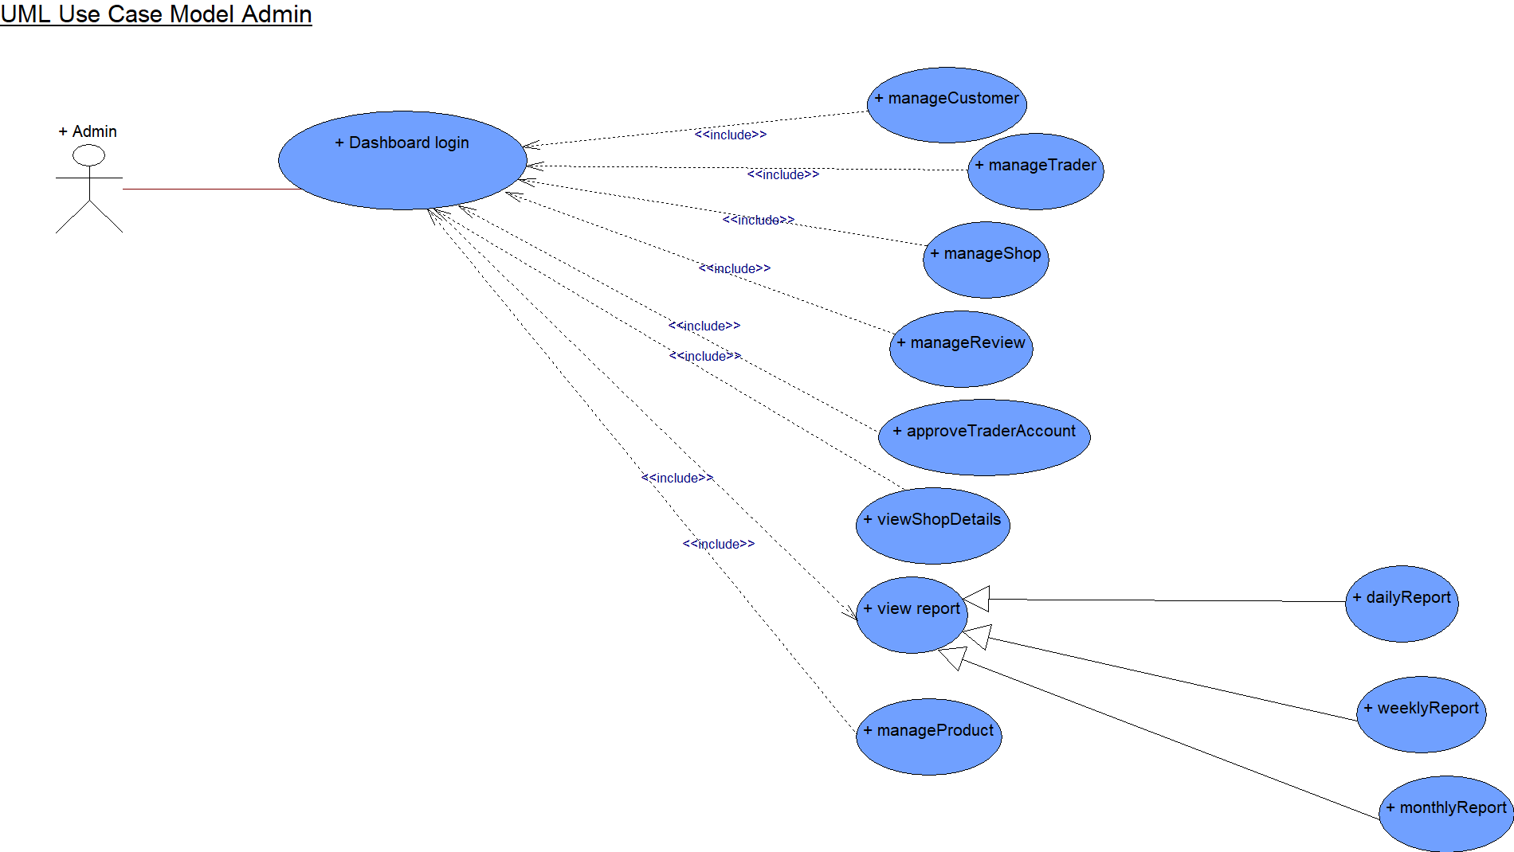

## Requirement Catalogue

### MoSCoW Requirements

**PART A: Customer Interface**

|  |  |  |
| --- | --- | --- |
| ***Requirement ID*** | ***Description*** | ***MoSCoW*** |
| **A1** | **Website interactions** |  |
| A1-1 | Users should be able to access to products by shop or by product type. | M |
| A1-2 | The site should be responsive and should be viewable on mobile as well as desktop devices and viewable on the most popular browsers. | M |
| A1-3 | A basket function that keeps goods that spans all traders and requires a single payment for every user. | M |
| A1-4 | The system should be able to keep a maximum of 10 shops(traders). | S |
| A1-5 | The design of the website should be based on Cleckhuddersfaxtheme. | S |
| A1-6 | The cart and totals reported to the traders should include a breakdown of goods ordered and payment acquired by trader. |  |
| A1-7 | There should be a maximum of 20 orders per slot. | S |
| **A2** | **User’s interactions in the website** |  |
| A2-1 | Users should be required to register on the website before they can place an order and be logged in with their account to access the basket. | M |
| A2-2 | There will be 3 collection slots 10-13,13-16, 16-19 which will be available Wednesday, ThursdayandFriday respectively. | M |
| A2-3 | When placing and paying for their order users should identify a collection slot, which must be at least 24 hours after placing the order. | M |
| A2-4 | PayPal will be used as a form of payment. | M |
| A2-5 | Users should be able to view and manage their account details. | W |
| A2-6 | Registration and account updates should be confirmed via interaction with emails. | W |

**PART B: Trader Interface**

|  |  |  |
| --- | --- | --- |
| ***Requirement ID*** | ***Description*** | ***MoSCoW*** |
| **B1** | **Trader interactions with the website** |  |
| B1-1 | Traders should be able to control their products and data on their shops via a web interface. | M |
| B1-2 | Traders should be able to update/delete/add their required products. | M |
| B1-3 | Traders will login to the database on a daily basis to view reports on orders and stocks information etc. | M |
| B1-4 | Traders should have a trader login that allows them access to their details only. | M |
| B1-5 | Traders should be able to view and supervise the details of their separate trader account. | M |
| B1-6 | All products will have a unique ID, be associated with a trader, have a short name, a description, an item price, quantity per item, stock available, min order, max order and allergy information. | C |

**Part C: Management Interface**

|  |  |  |
| --- | --- | --- |
| ***Requirement ID*** | ***Description*** | ***MoSCoW*** |
| **C1** | **Admin Dashboard and reports.** |  |
| C1-1 | There should be a separate guidance dashboard for an admin. | M |
| C1-2 | An Adminlogin which can access any of the trader accounts. | M |
| C1-3 | Traders will be provided with a monthly data/statistic on their amount of product sales. | M |
| C1-4 | The daily report will identify the goods, quantities that have been ordered and the collection time slot. | S |
| C1-5 | Traders will be provided with a weekly finance record which will recognize payments to be made to them resulting from the remainders of 7 days orders. | S |
| C1-6 | Traders will be able to pass this report ordered in a number of ways: by alphabetically, by total number of orders per product and by total cost per product. | S |
| C1-7 | Dashboard will give a range of daily and monthly reports. | C |

**PART D: Product Interface**

|  |  |  |
| --- | --- | --- |
| ***Requirement ID*** | ***Description*** | ***MoSCoW*** |
| **D1** | **The specifications for products kept on the website** |  |
| D1-1 | Each product will have its own required attributes. I.e.,product name, product ID, description, allergy information, price and product image. | M |
| D1-2 | Each product will have an add to cart option | M |
| D1-3 | Each product will have its own review section. | C |

**PART E: Non-Functional**

|  |  |  |
| --- | --- | --- |
| ***Requirement ID*** | ***Description*** | ***MoSCoW*** |
| **E1** | **The website will comply with the following nonfunctional requirements.** |  |
| E1-1 | HTML/CSS/ JavaScriptwill be used for building the website. | M |
| E1-2 | The sites files and folders will be properly managed, with a guide for Authorized people to access it. | M |
| E1-3 | PHP with Oracle Database will be used to build the site. | S |
| E1-4 | Template is used to view dashboard | S |

## Website Logo



## Wireframe

### Customer Wireframes

Cart

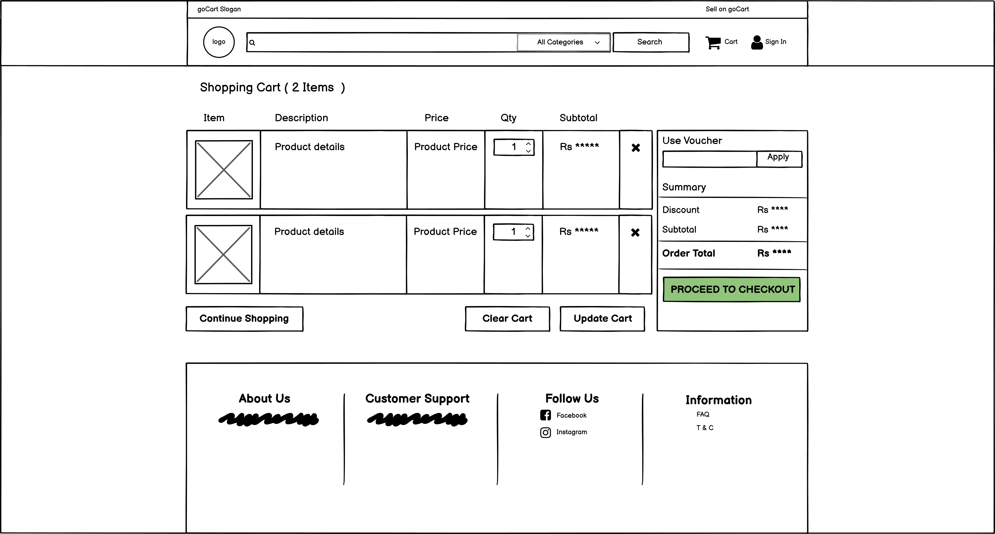

Checkout

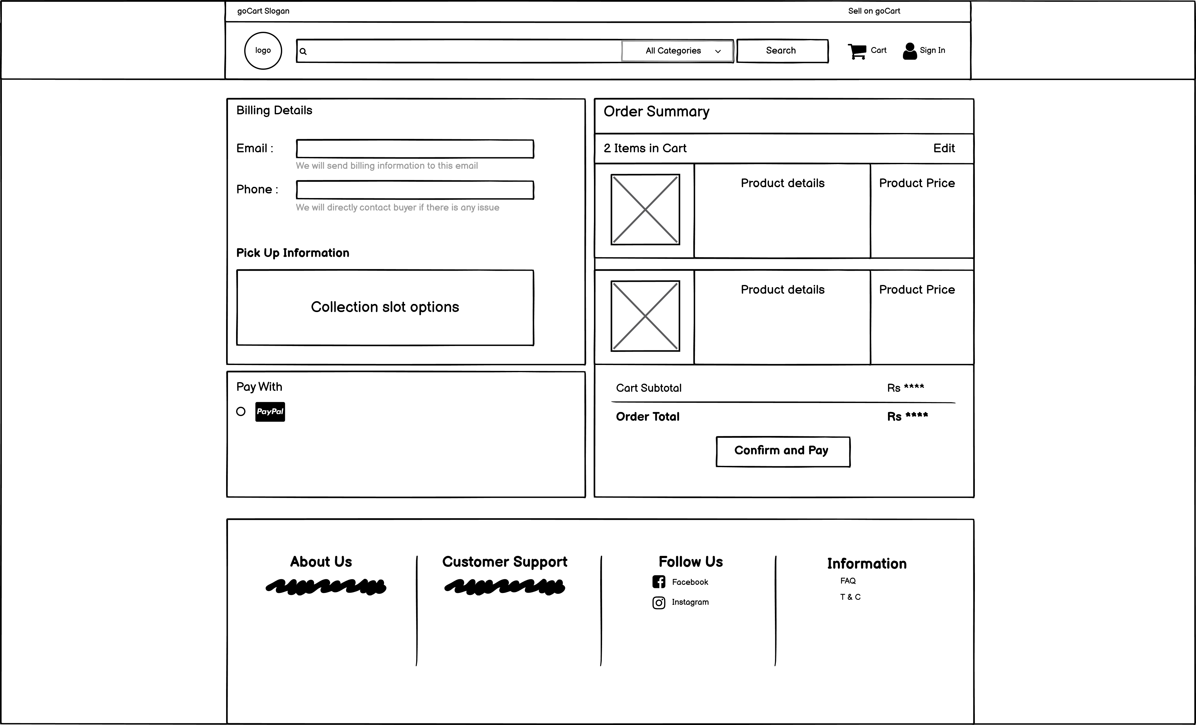

Customer Profile

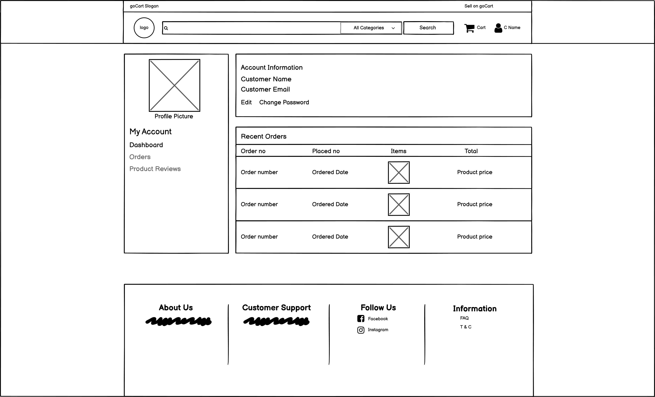

Edit Profile



Homepage

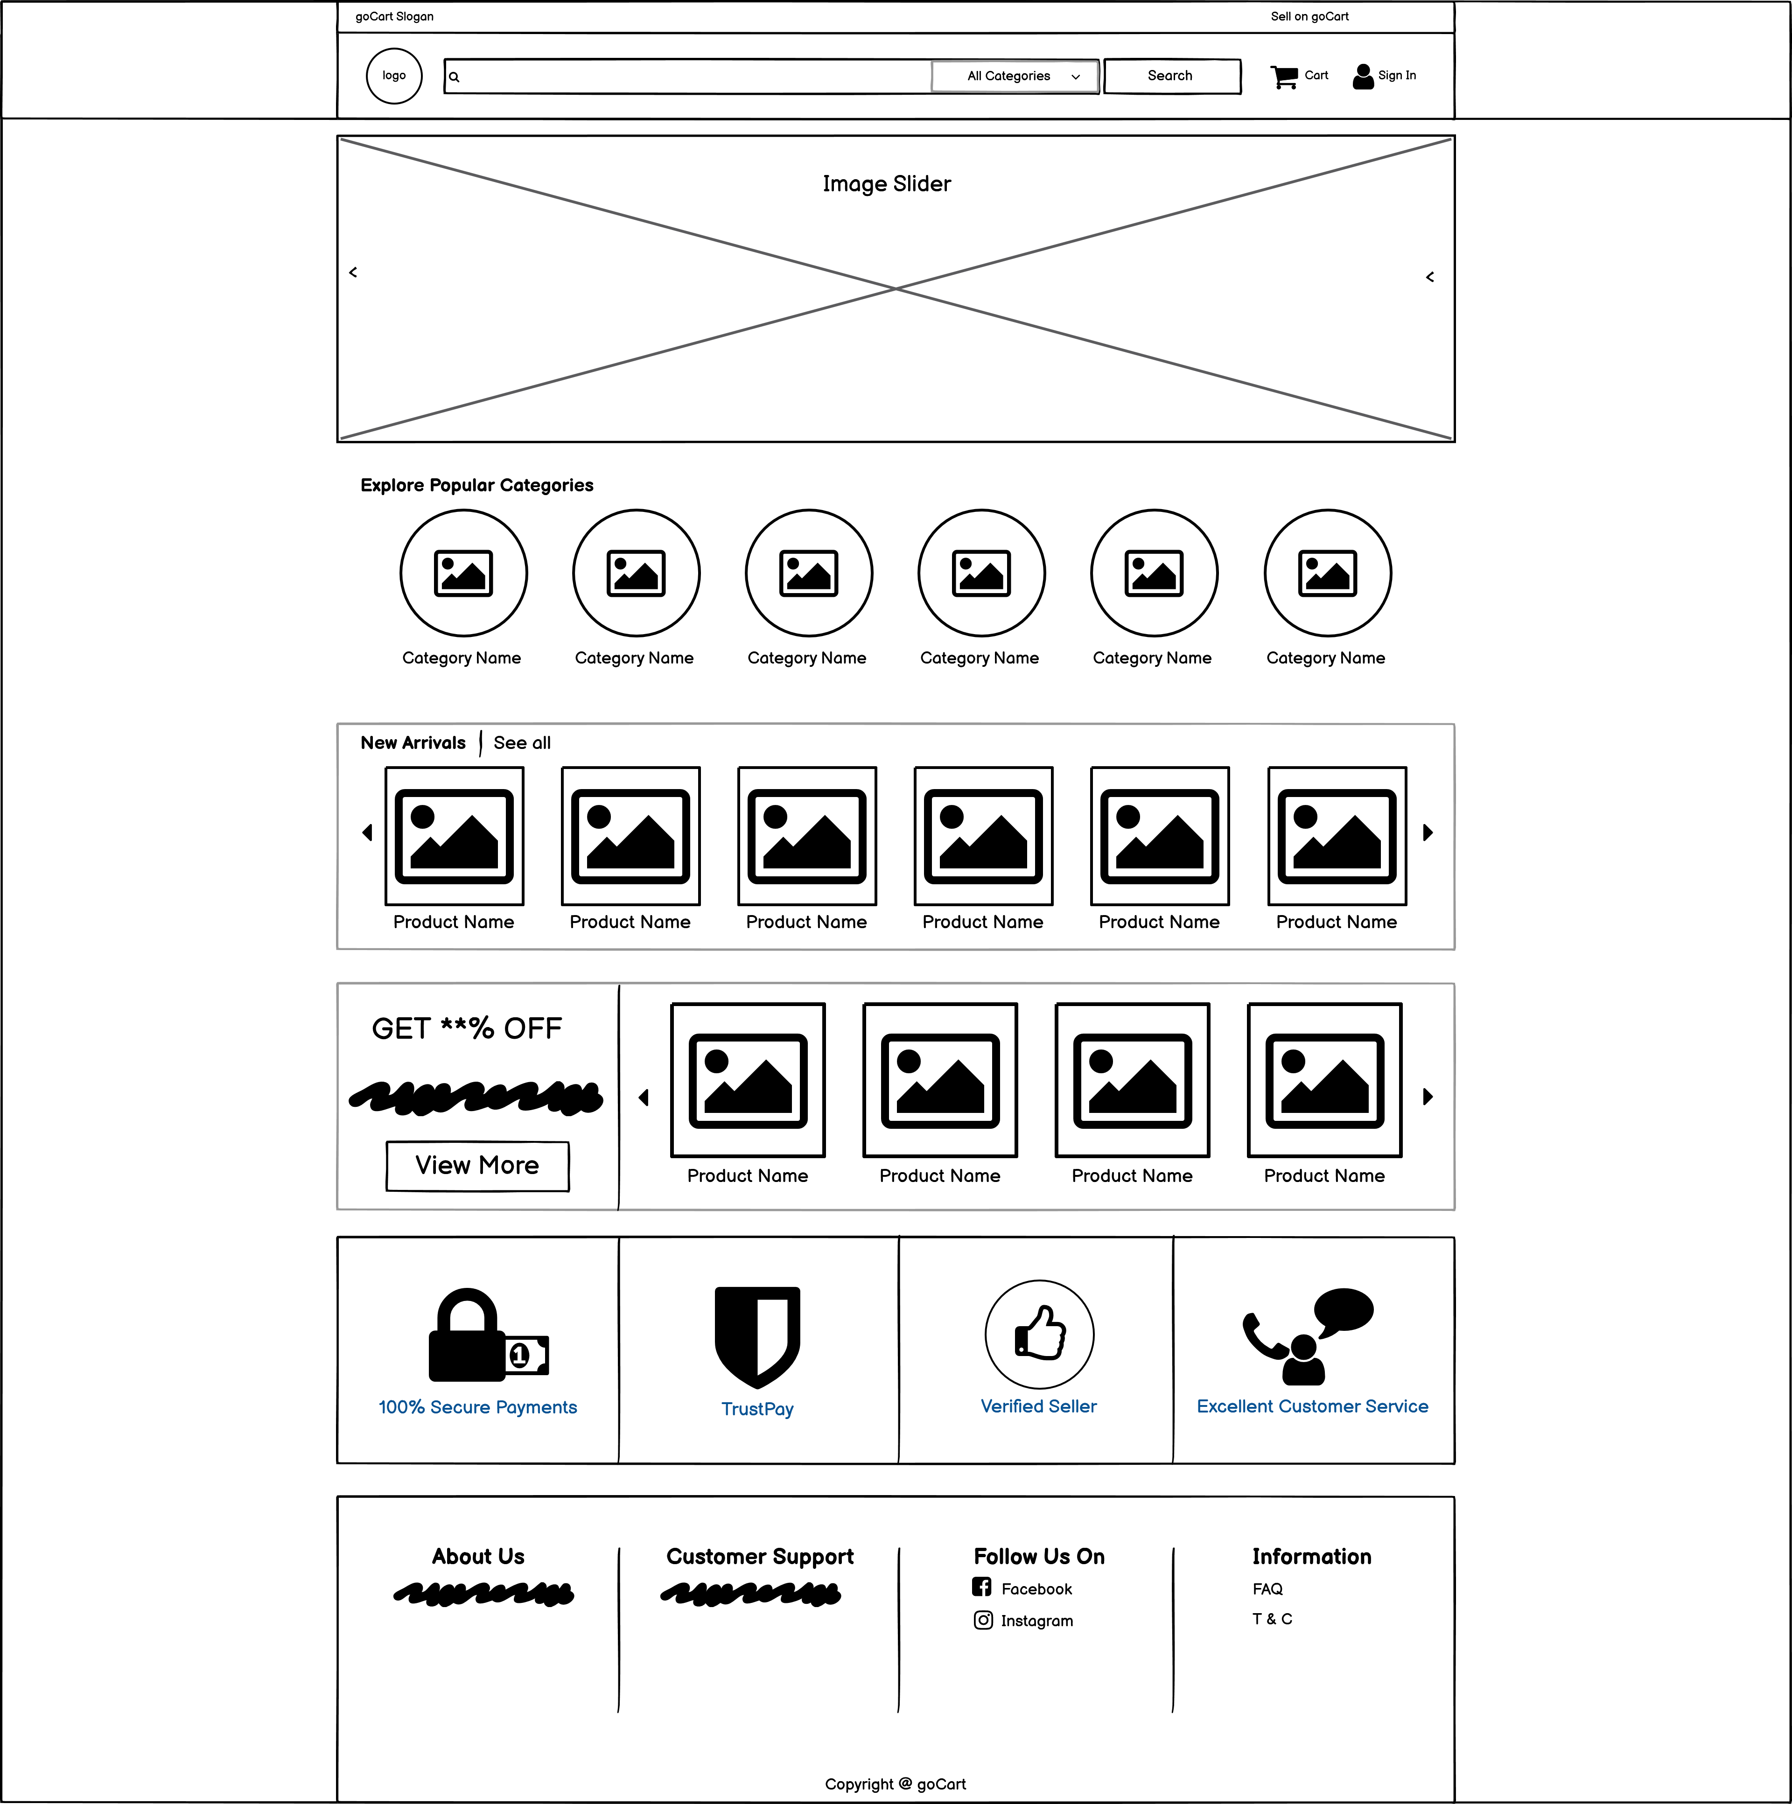

My Orders

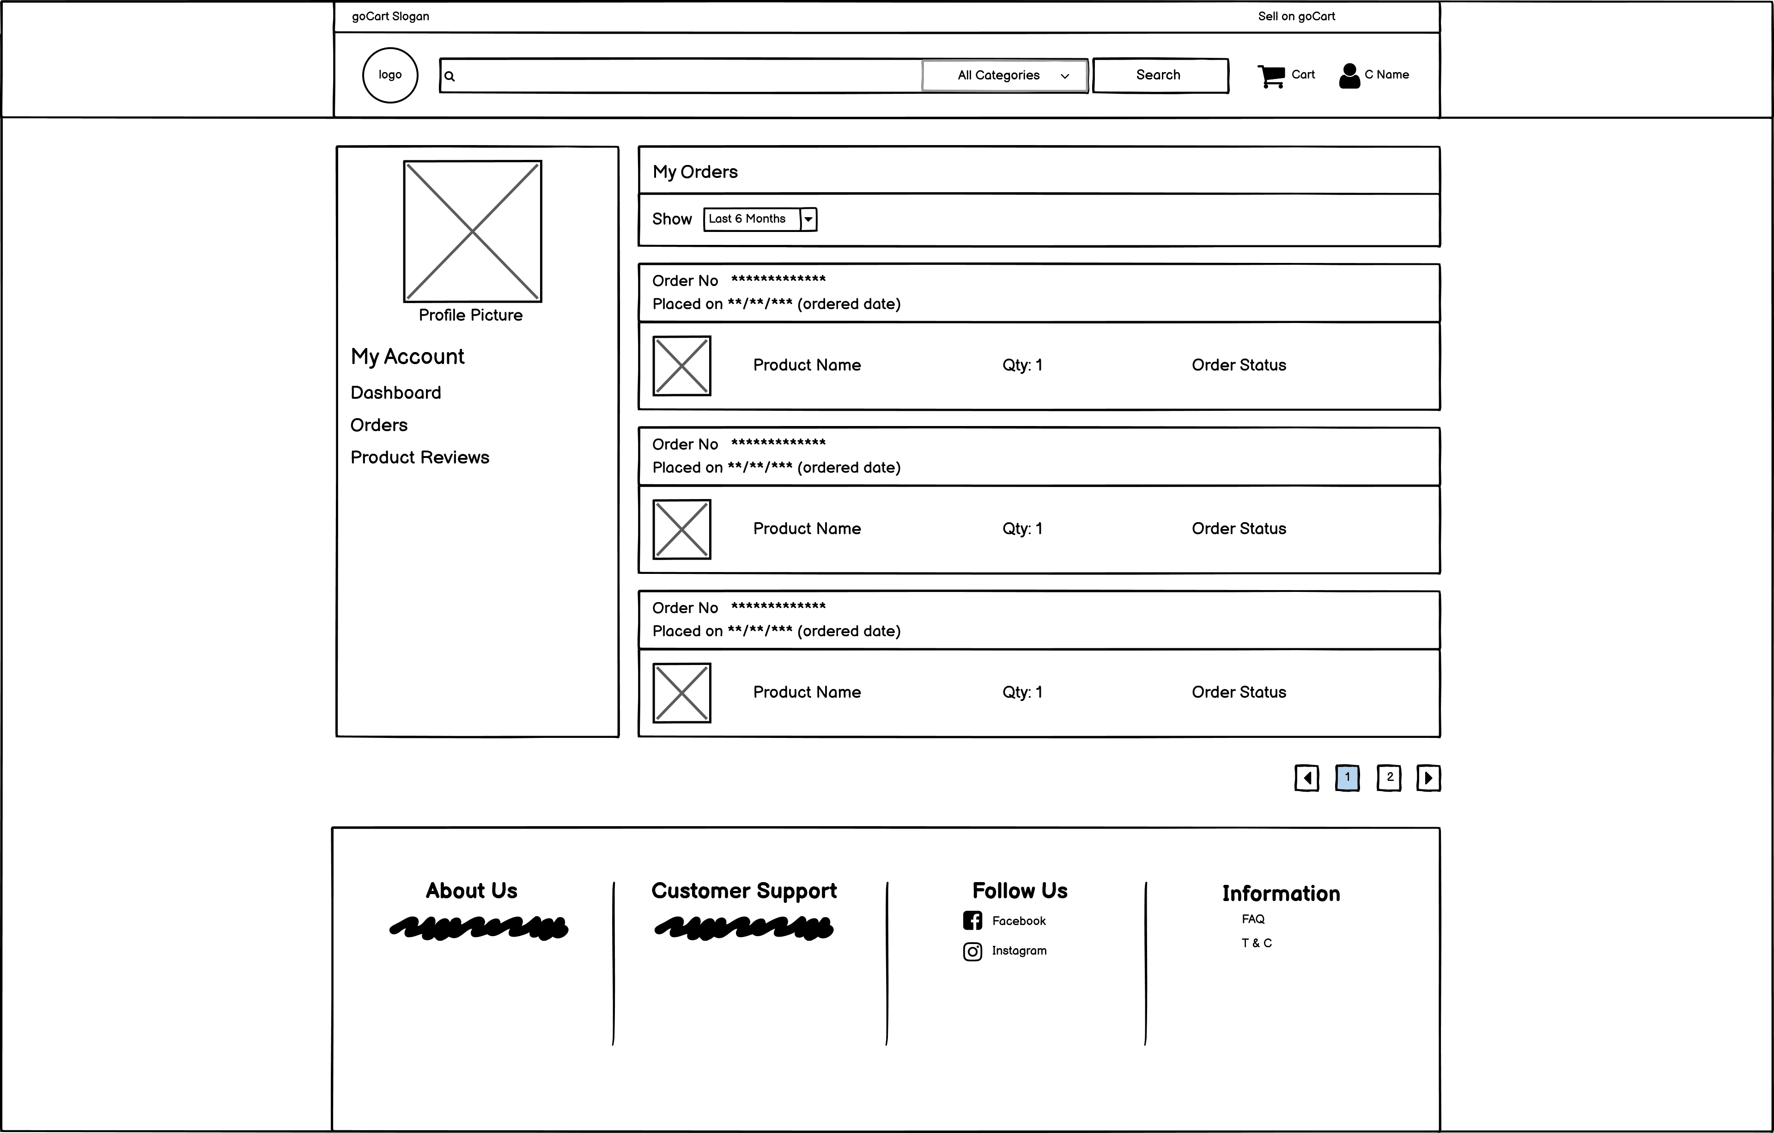

My Reviews

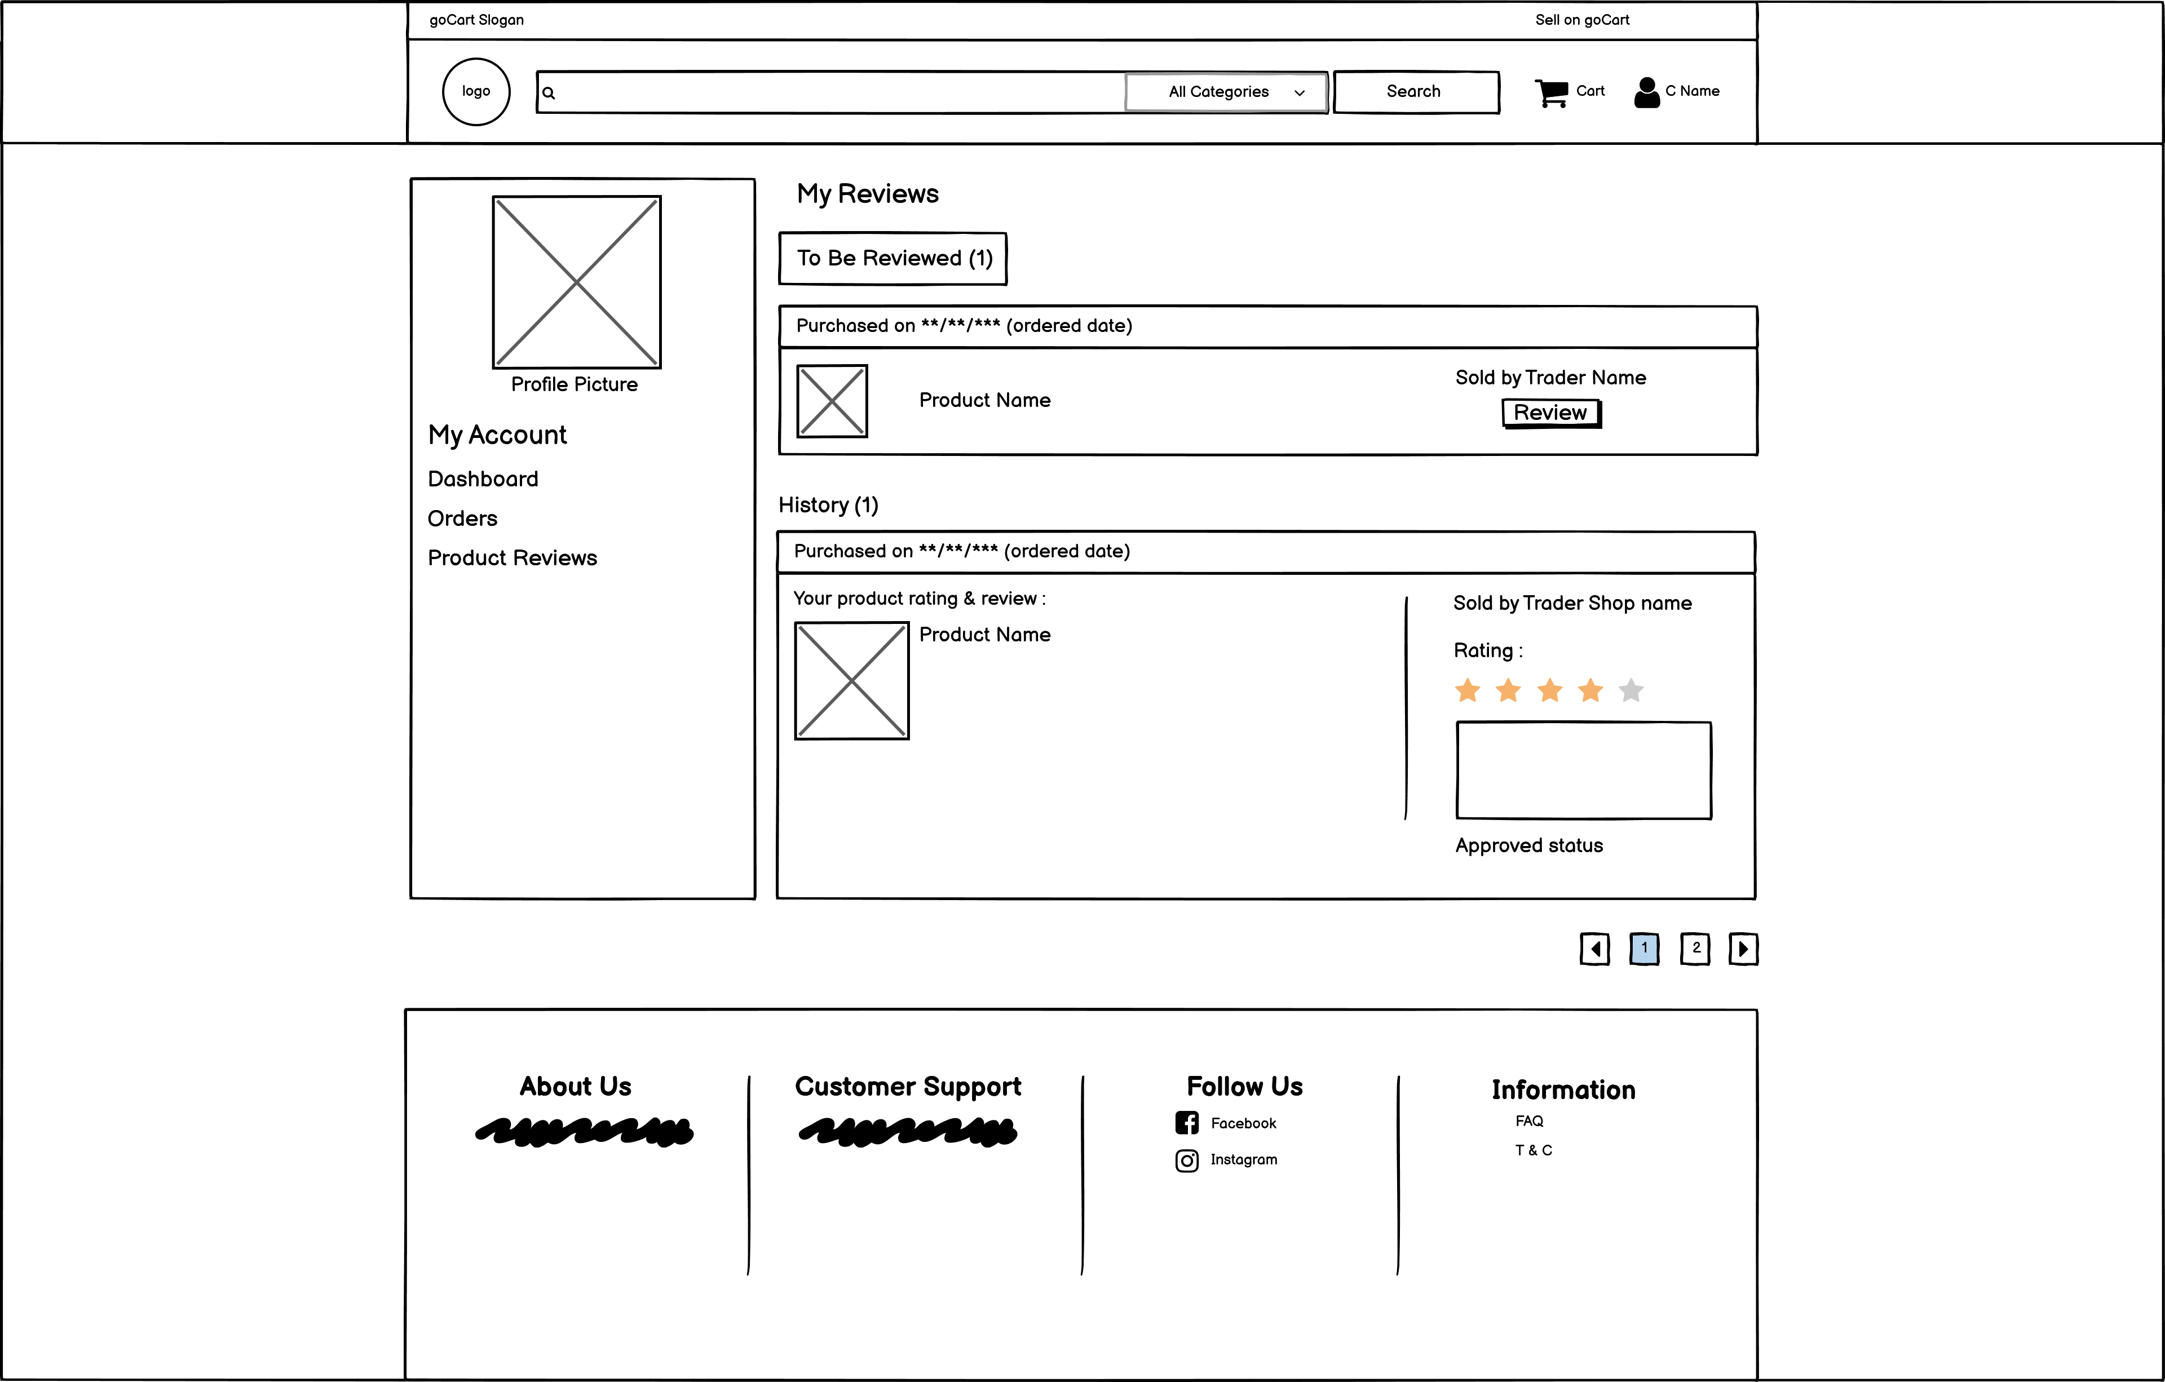

Product Details

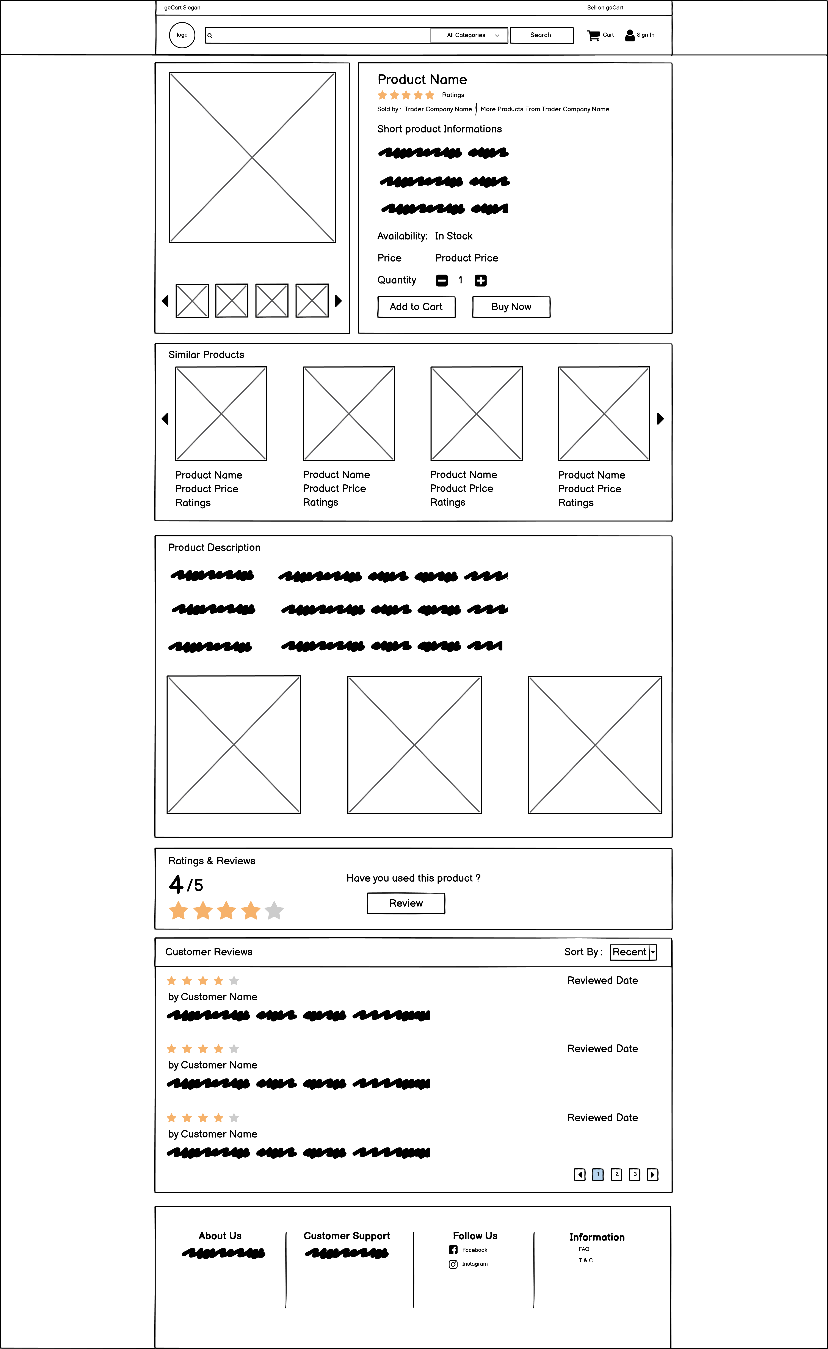

Search Product Result

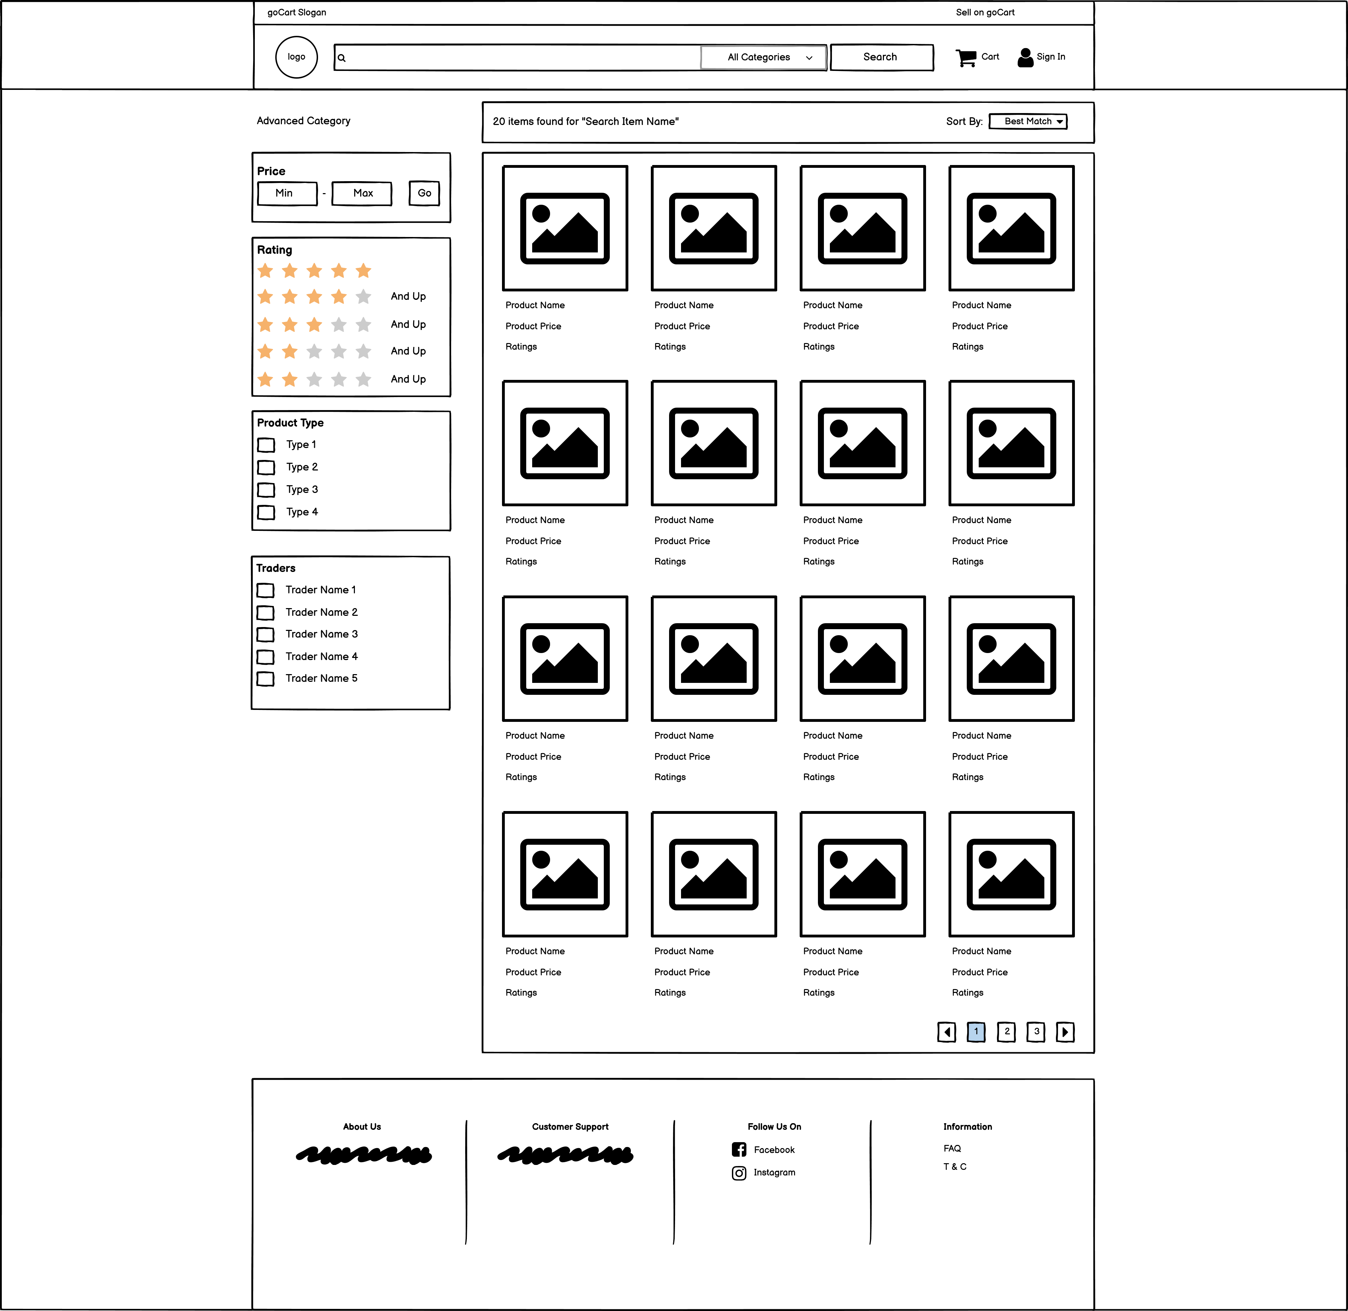

Sing In Customer

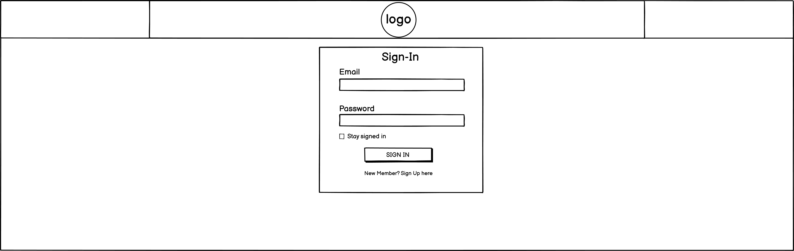

Sign Up Customer

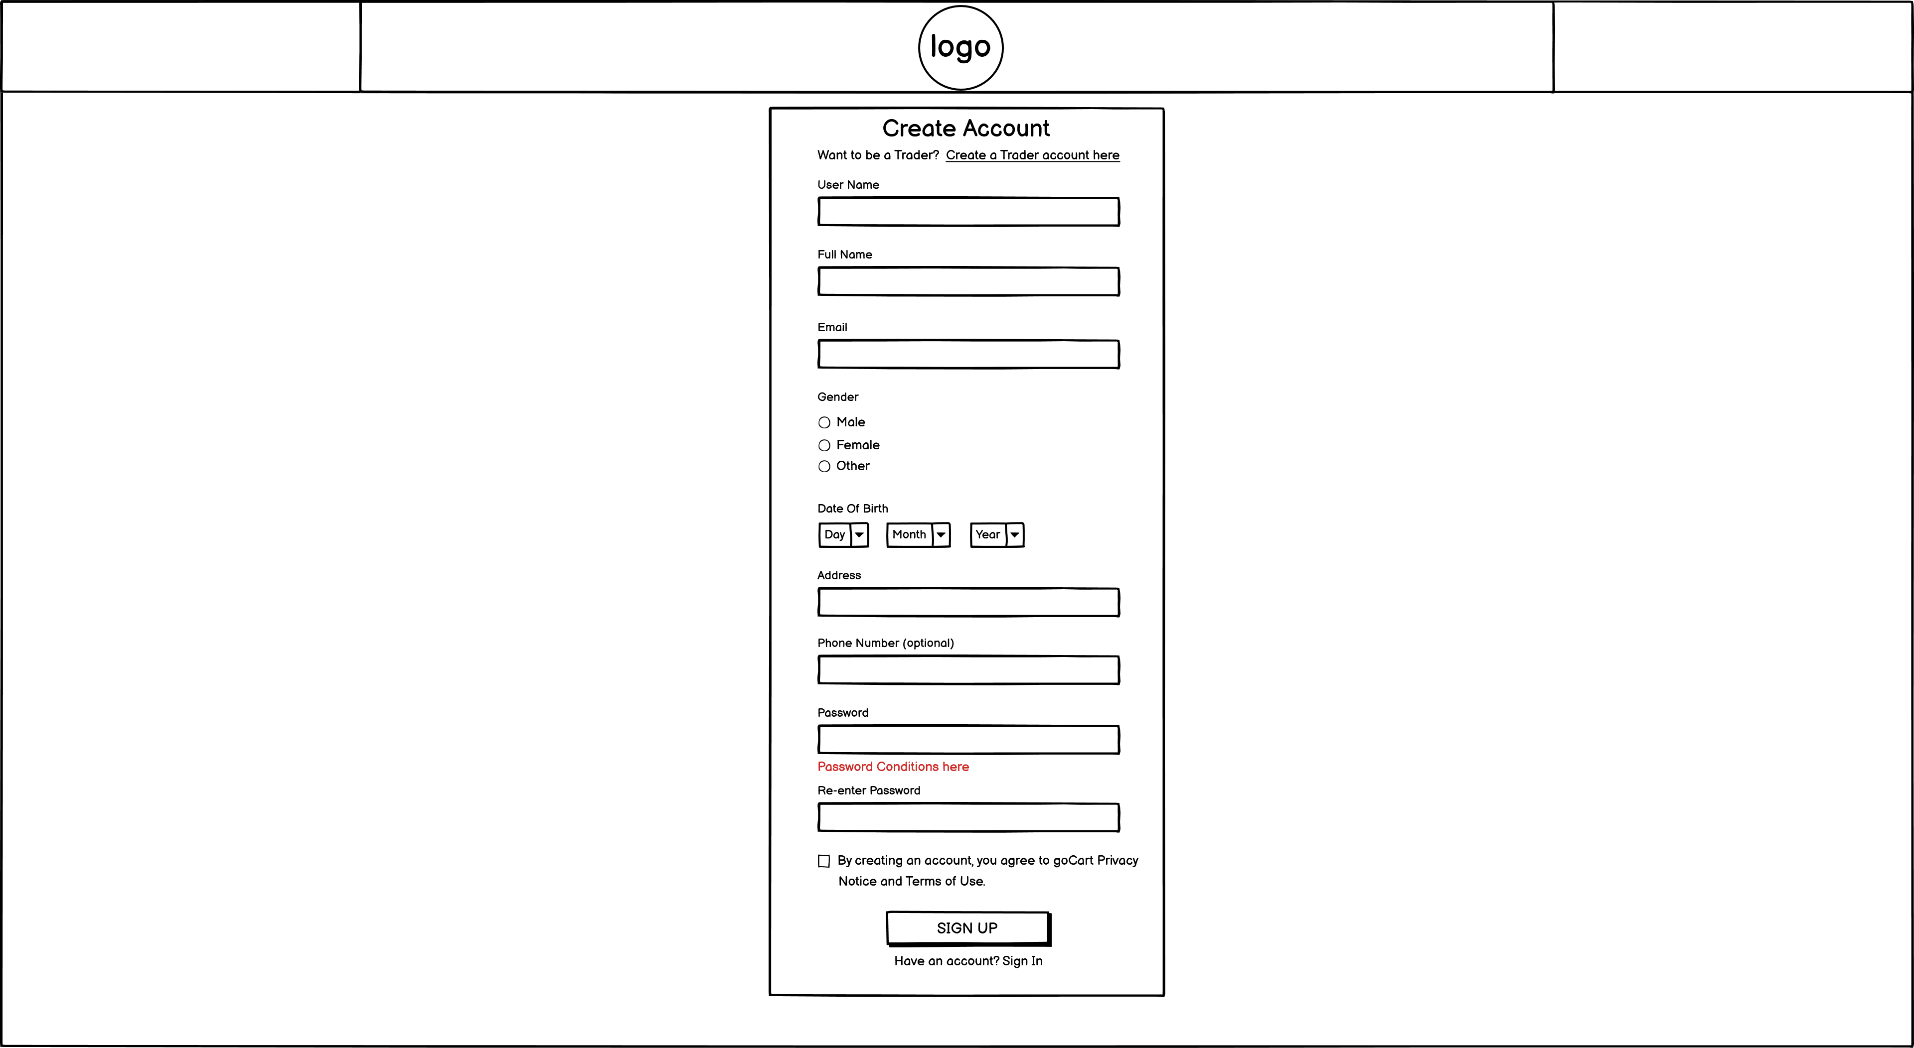

Successful Checkout

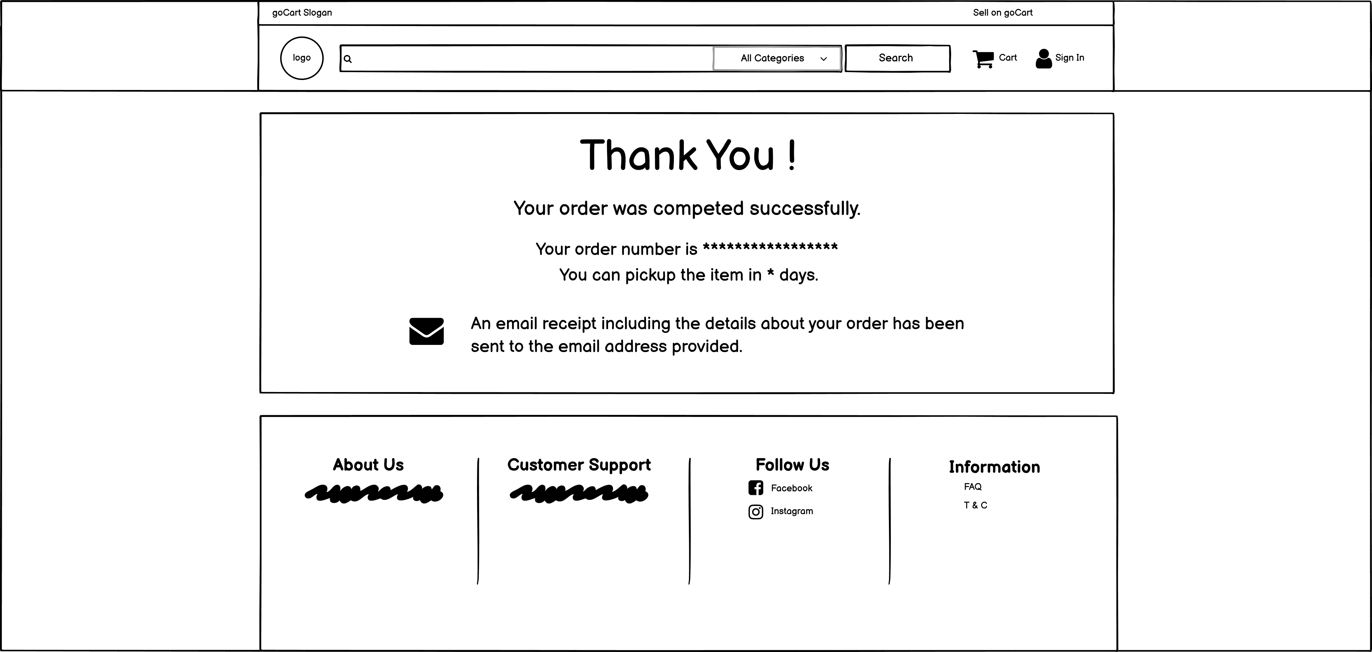

### Management Wireframes

Management New Products Approval

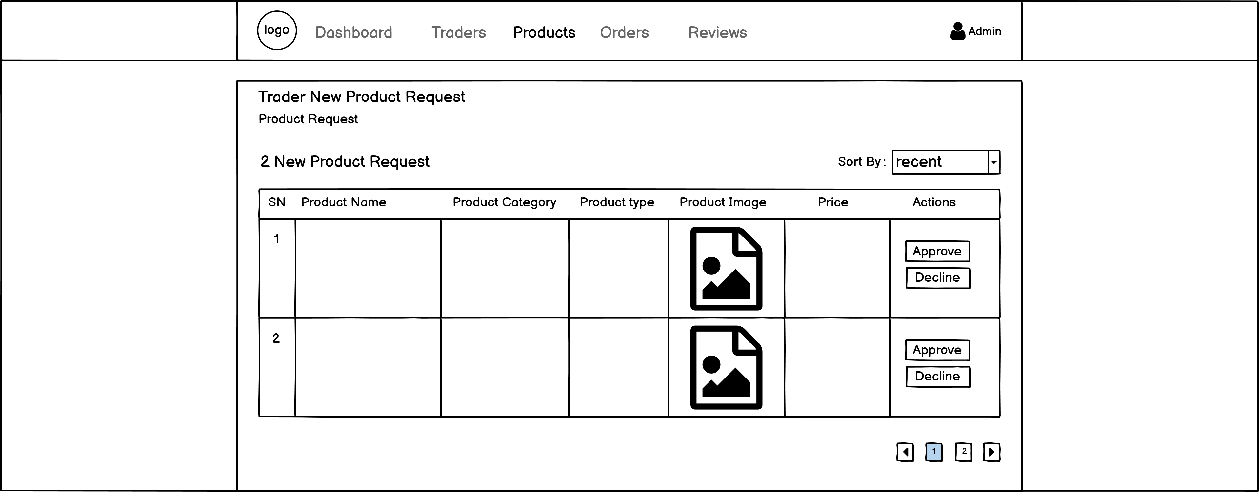

Management power to disable products

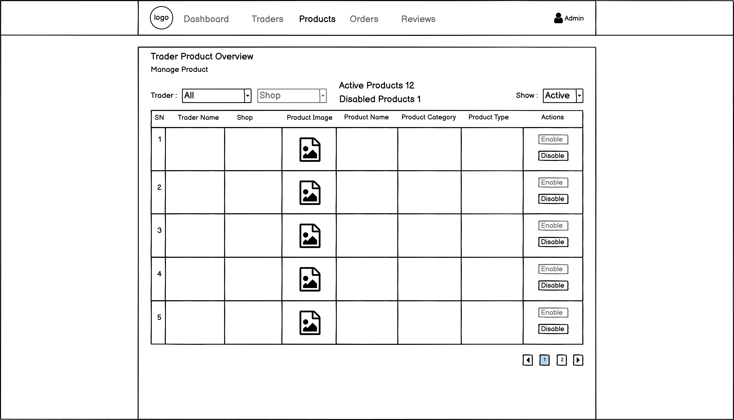

Management reviewers comment approve

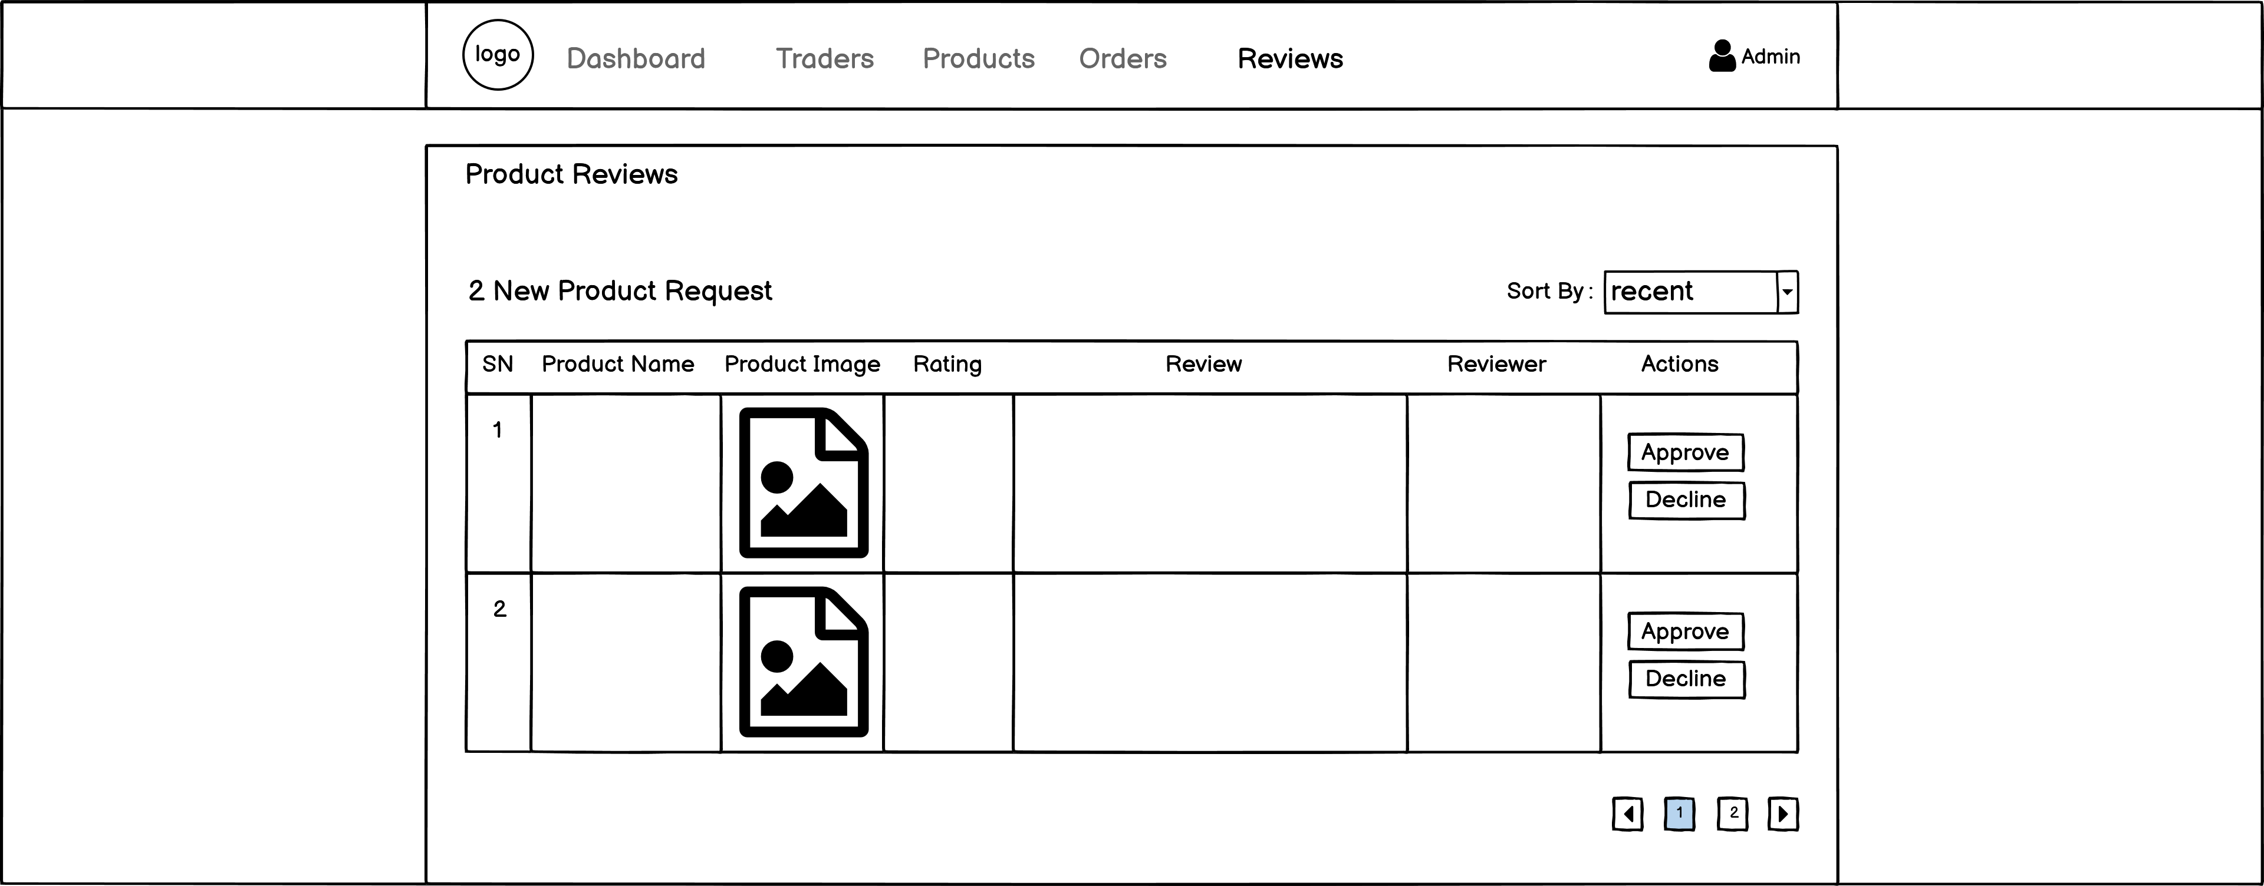

Management seller new account or shop request

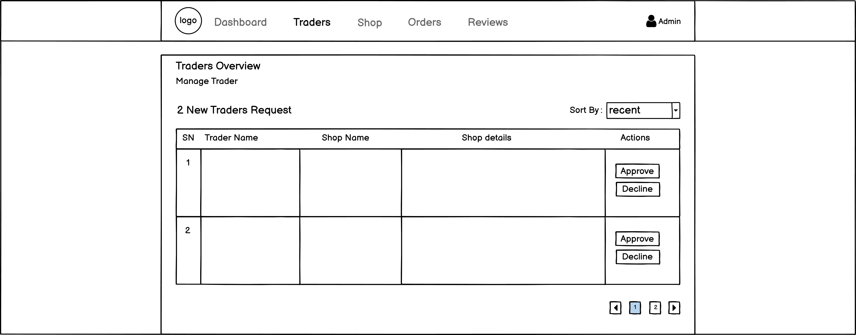

### Trader Wireframes

Add Product

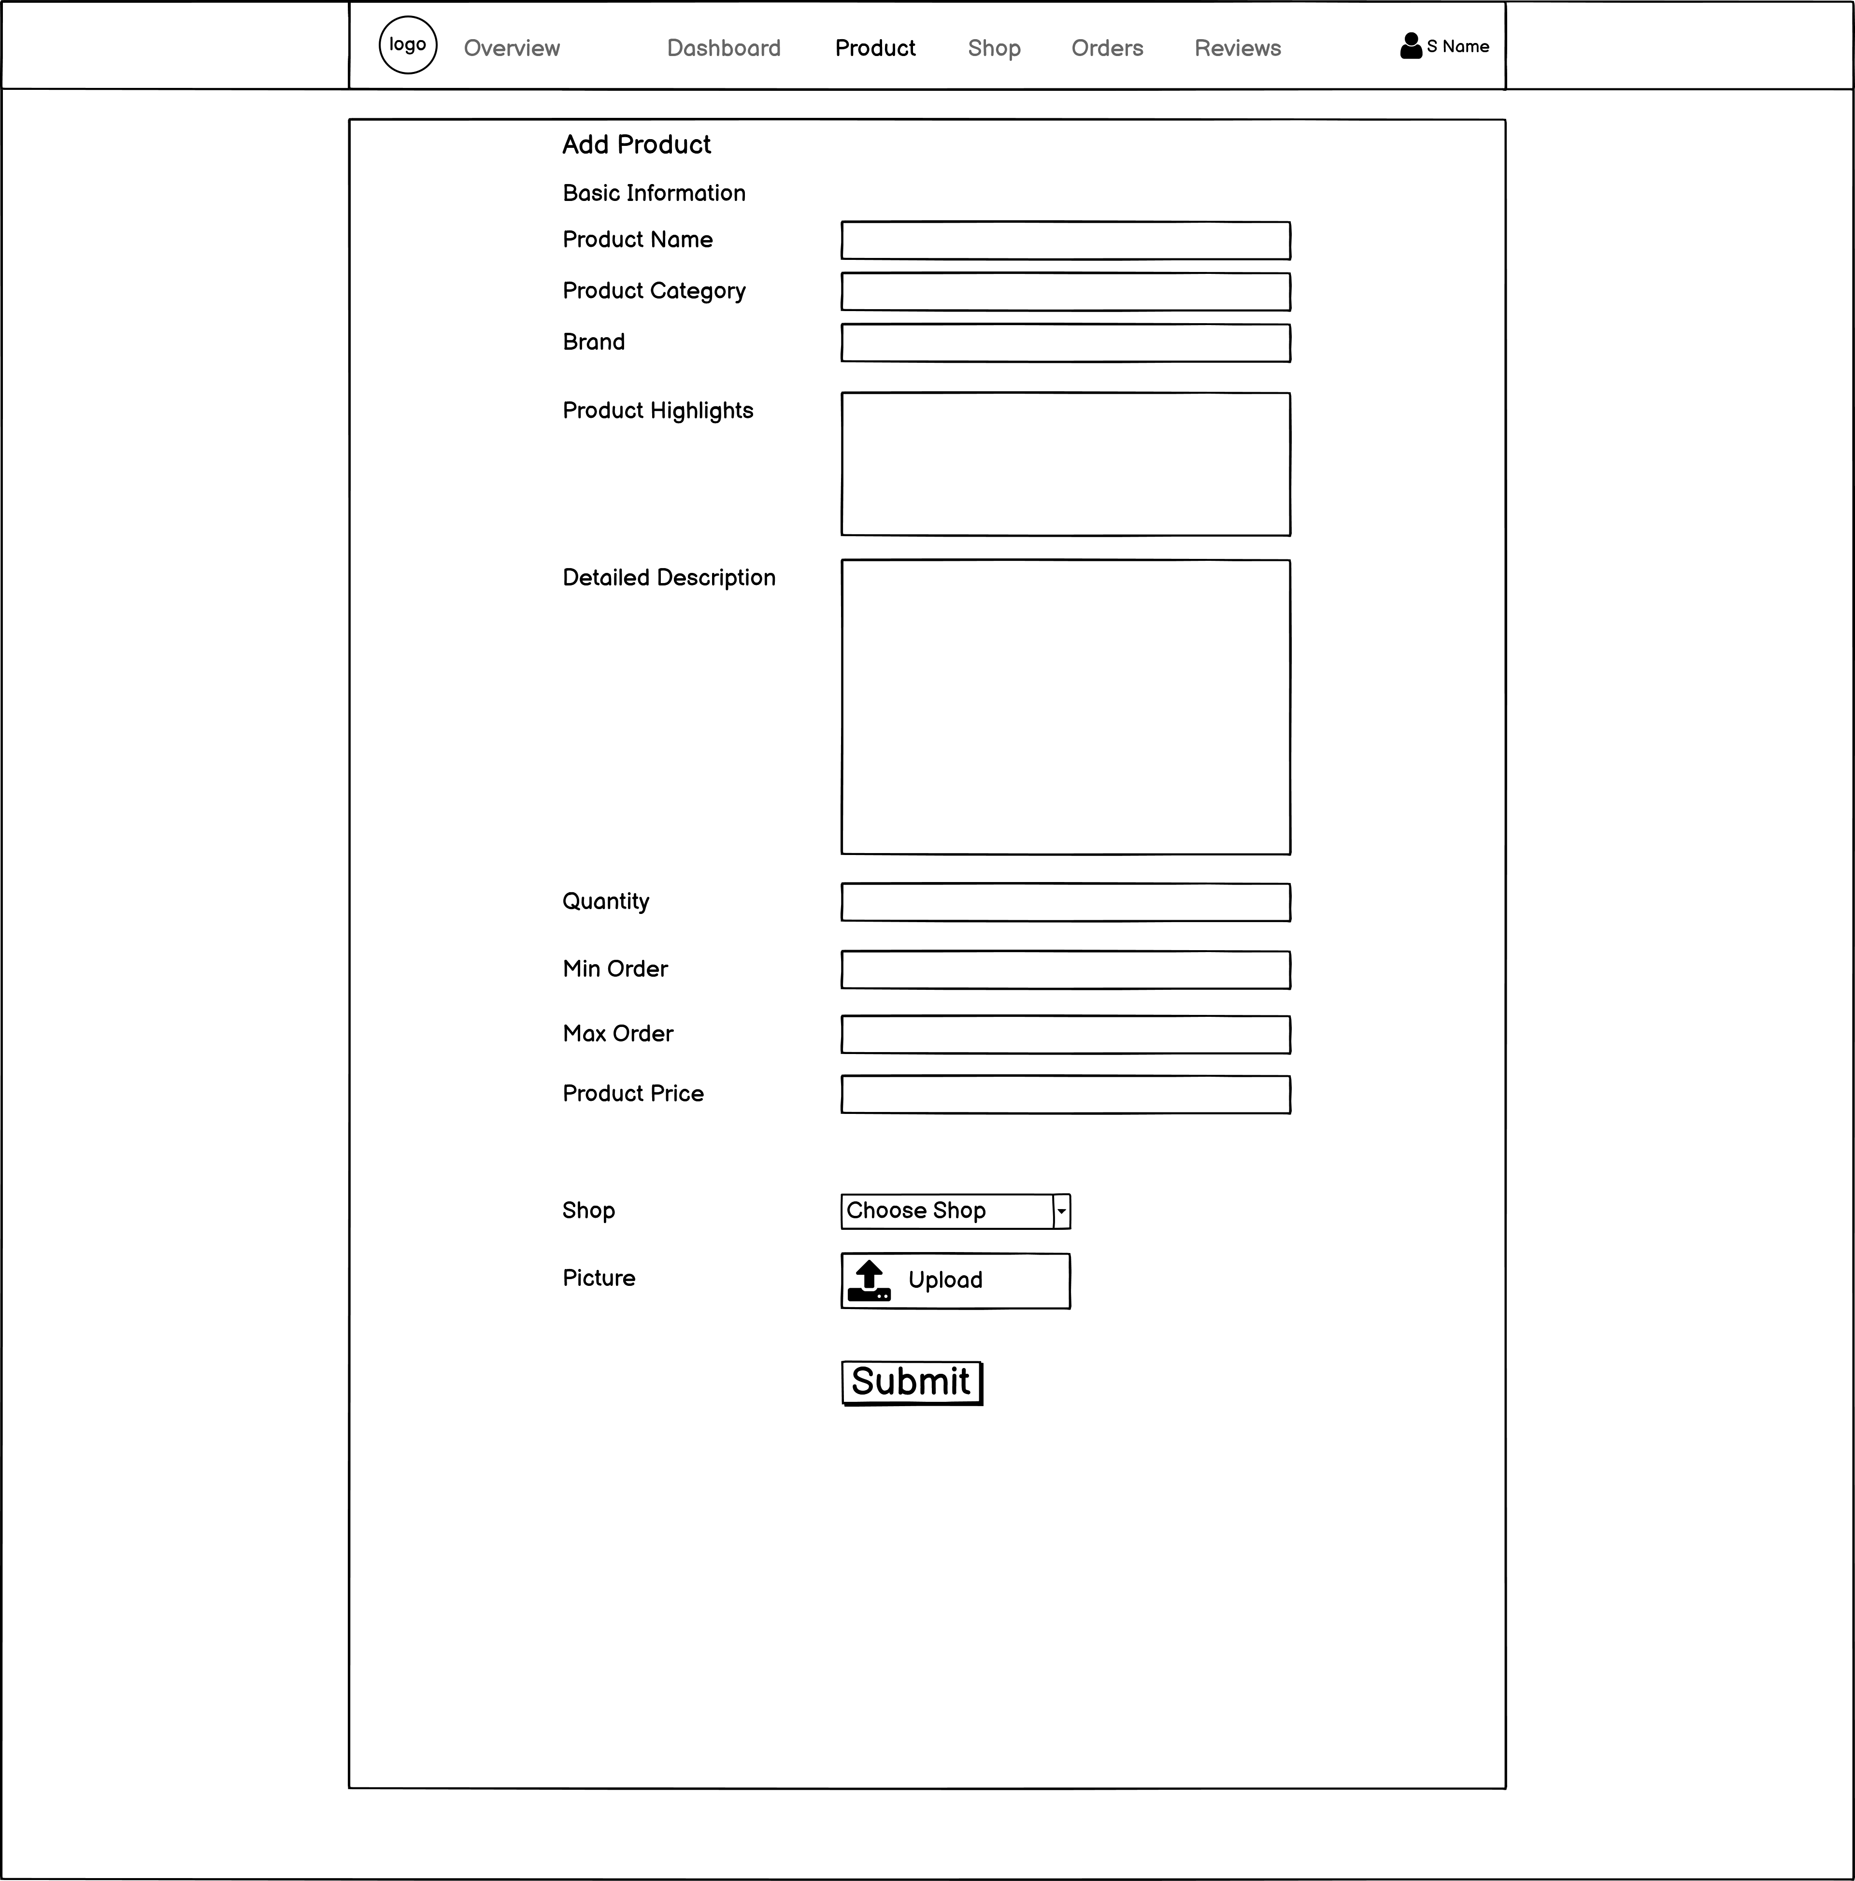

Edit Product

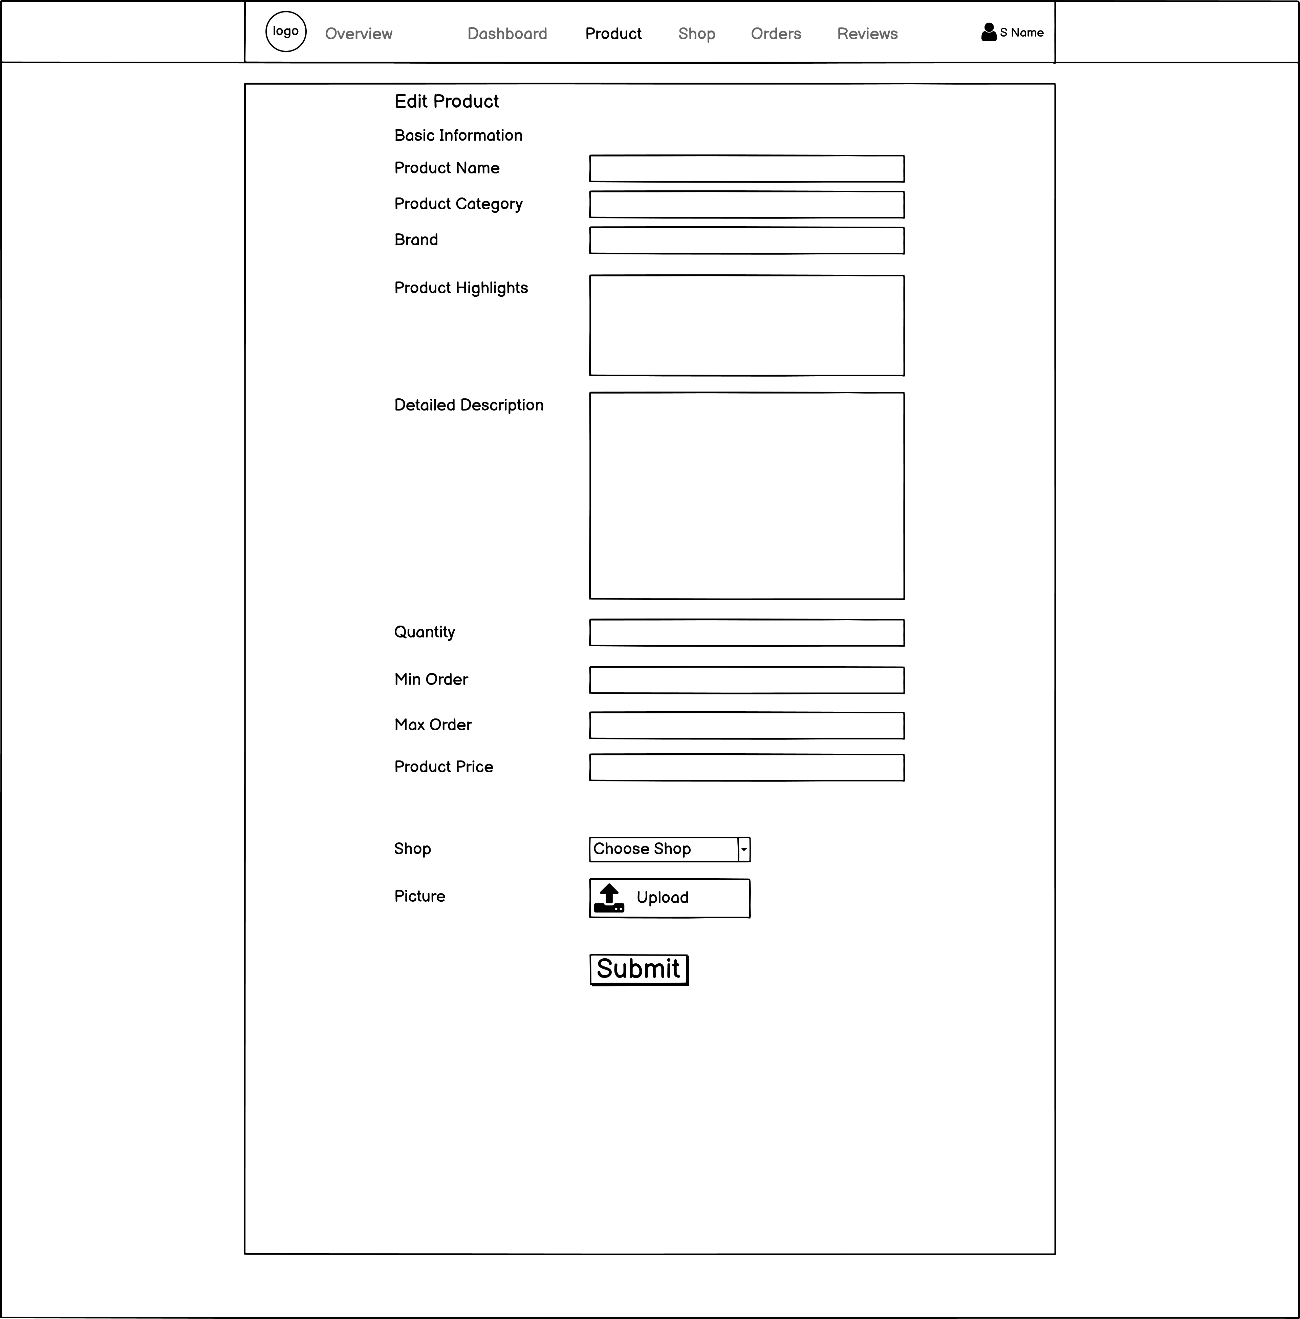

Sign In Trader

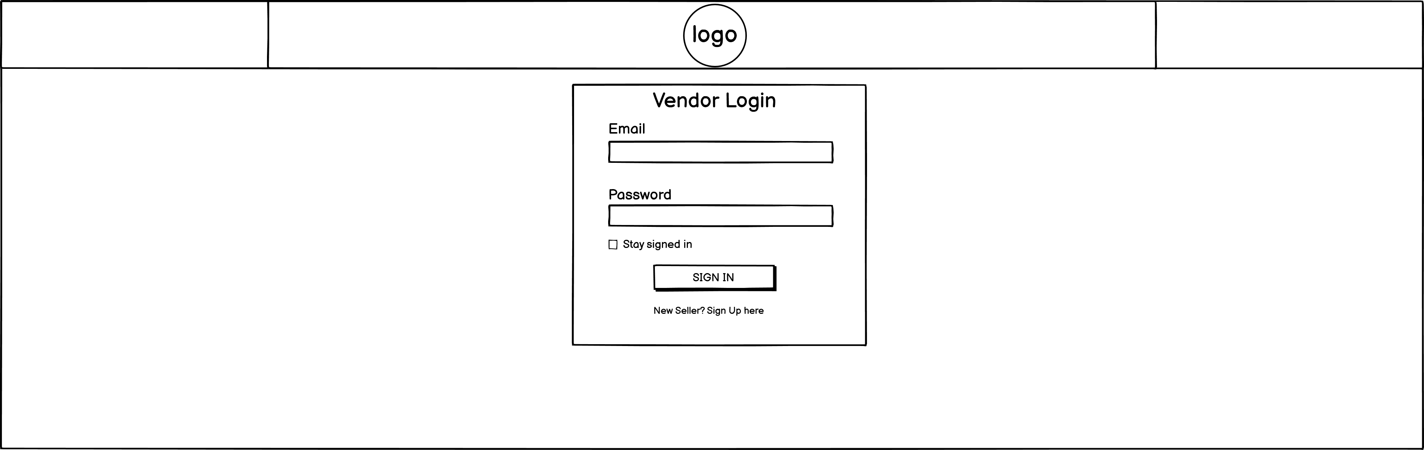

Sign up Trader

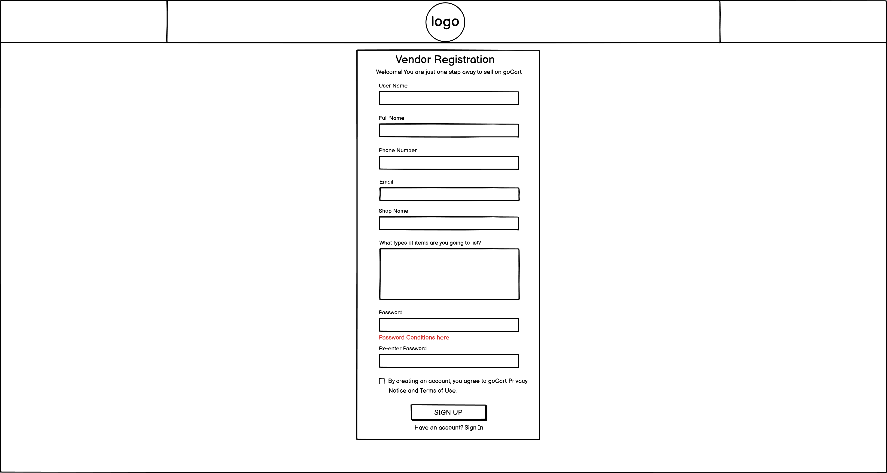

Trader add shop

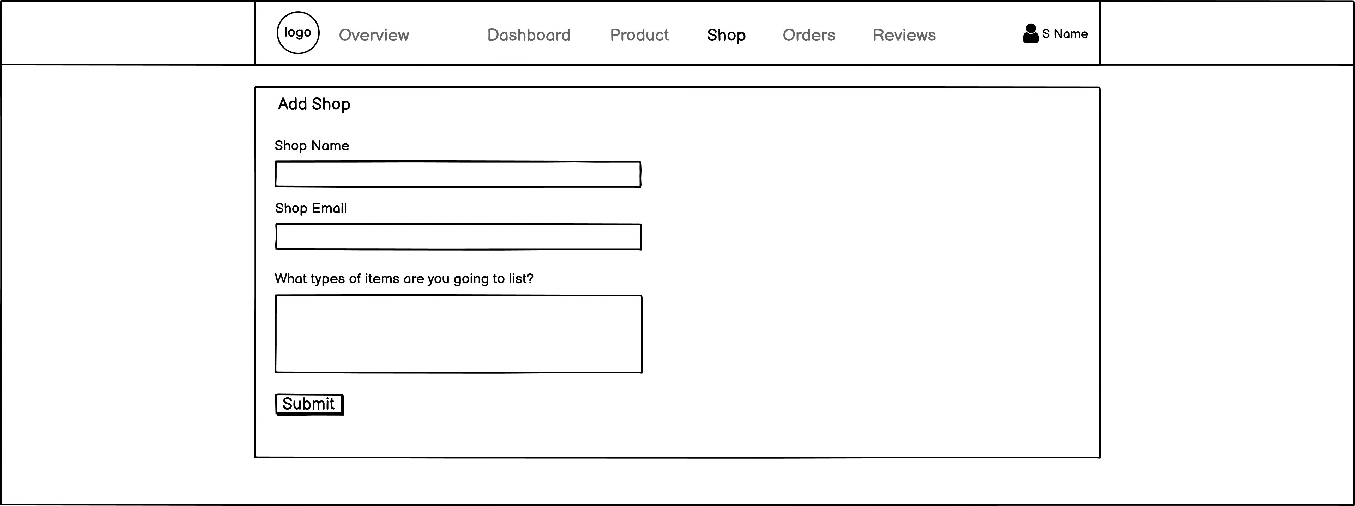

Trader edit profile

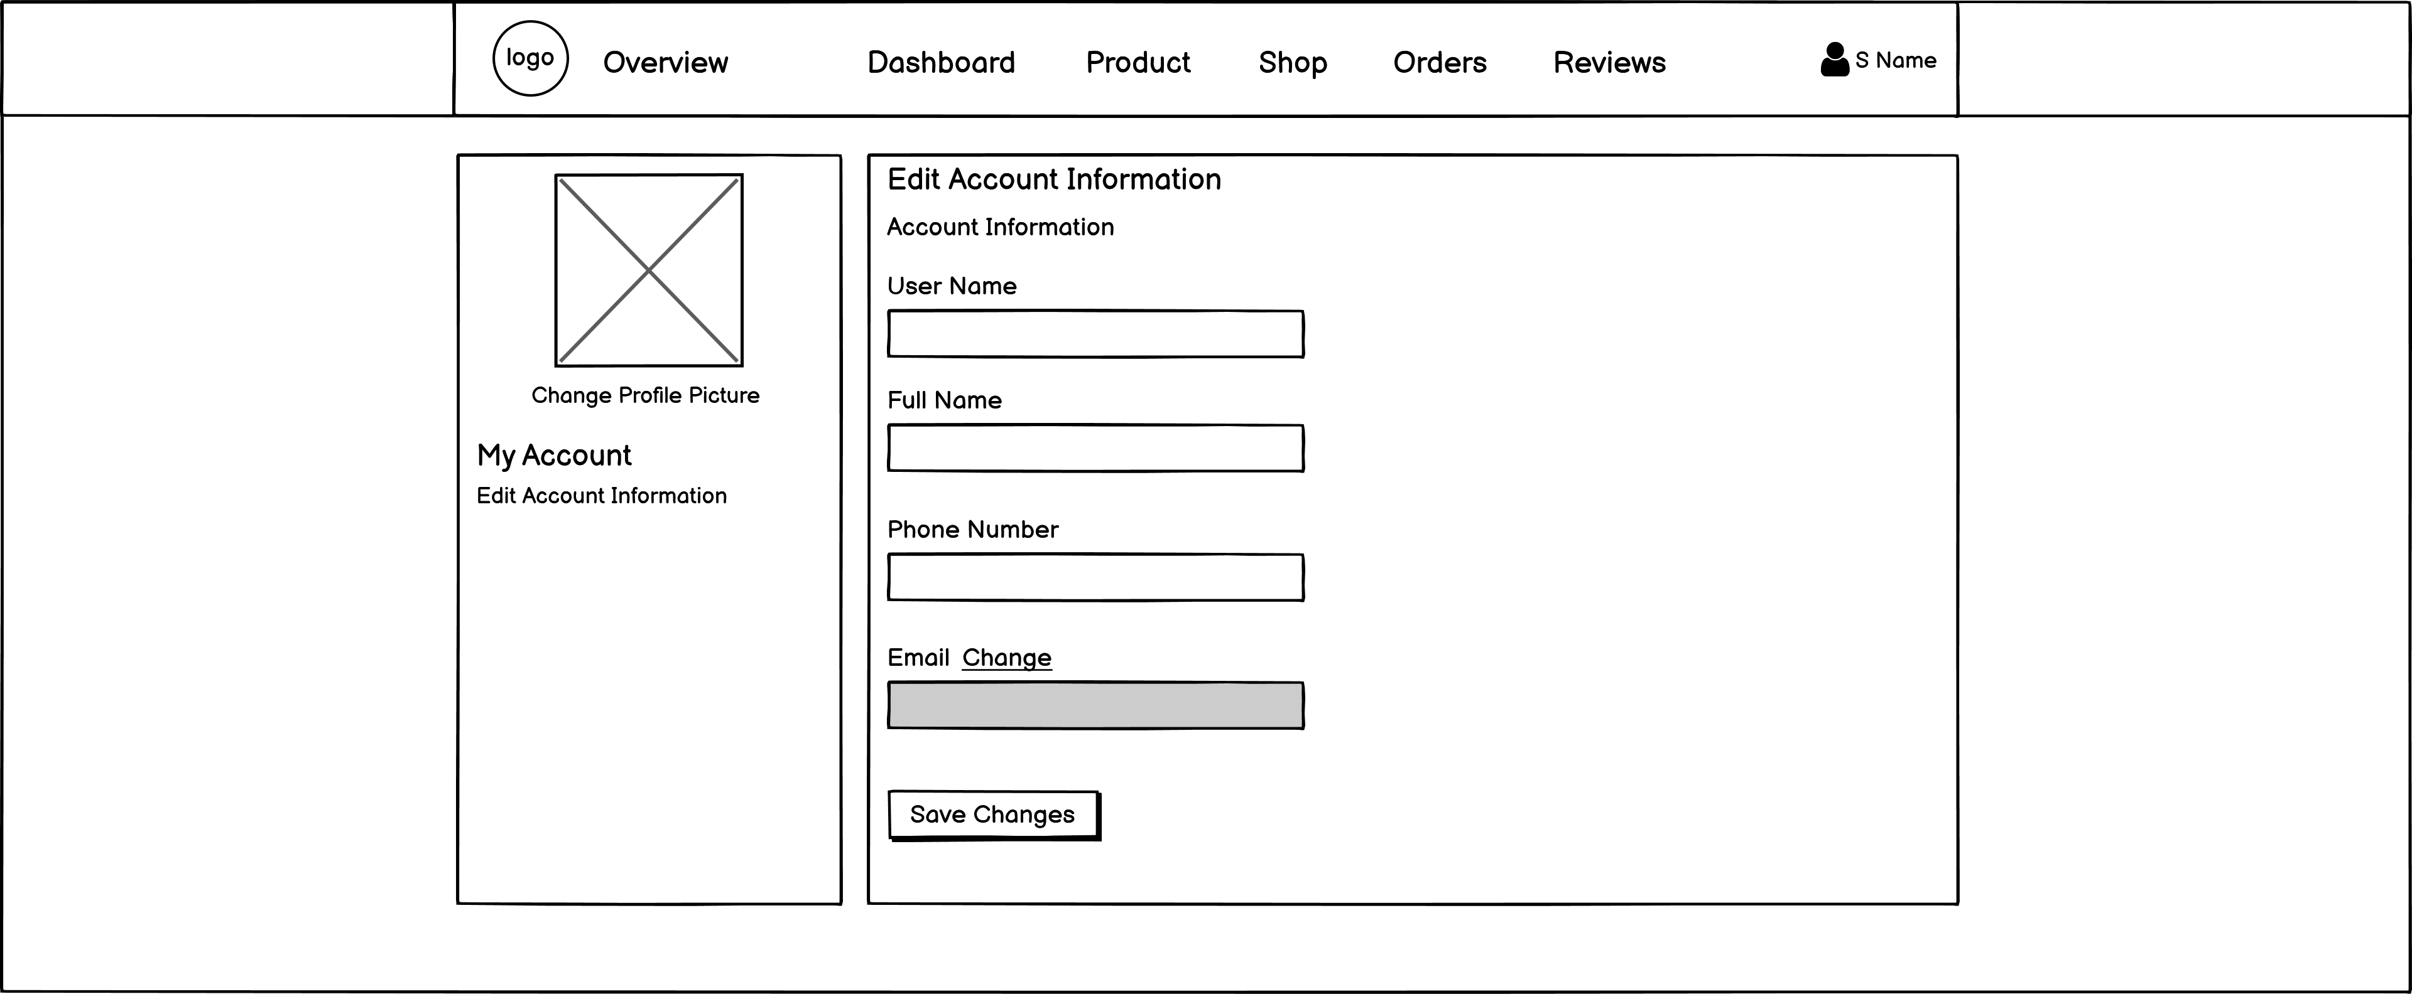

Trader Home

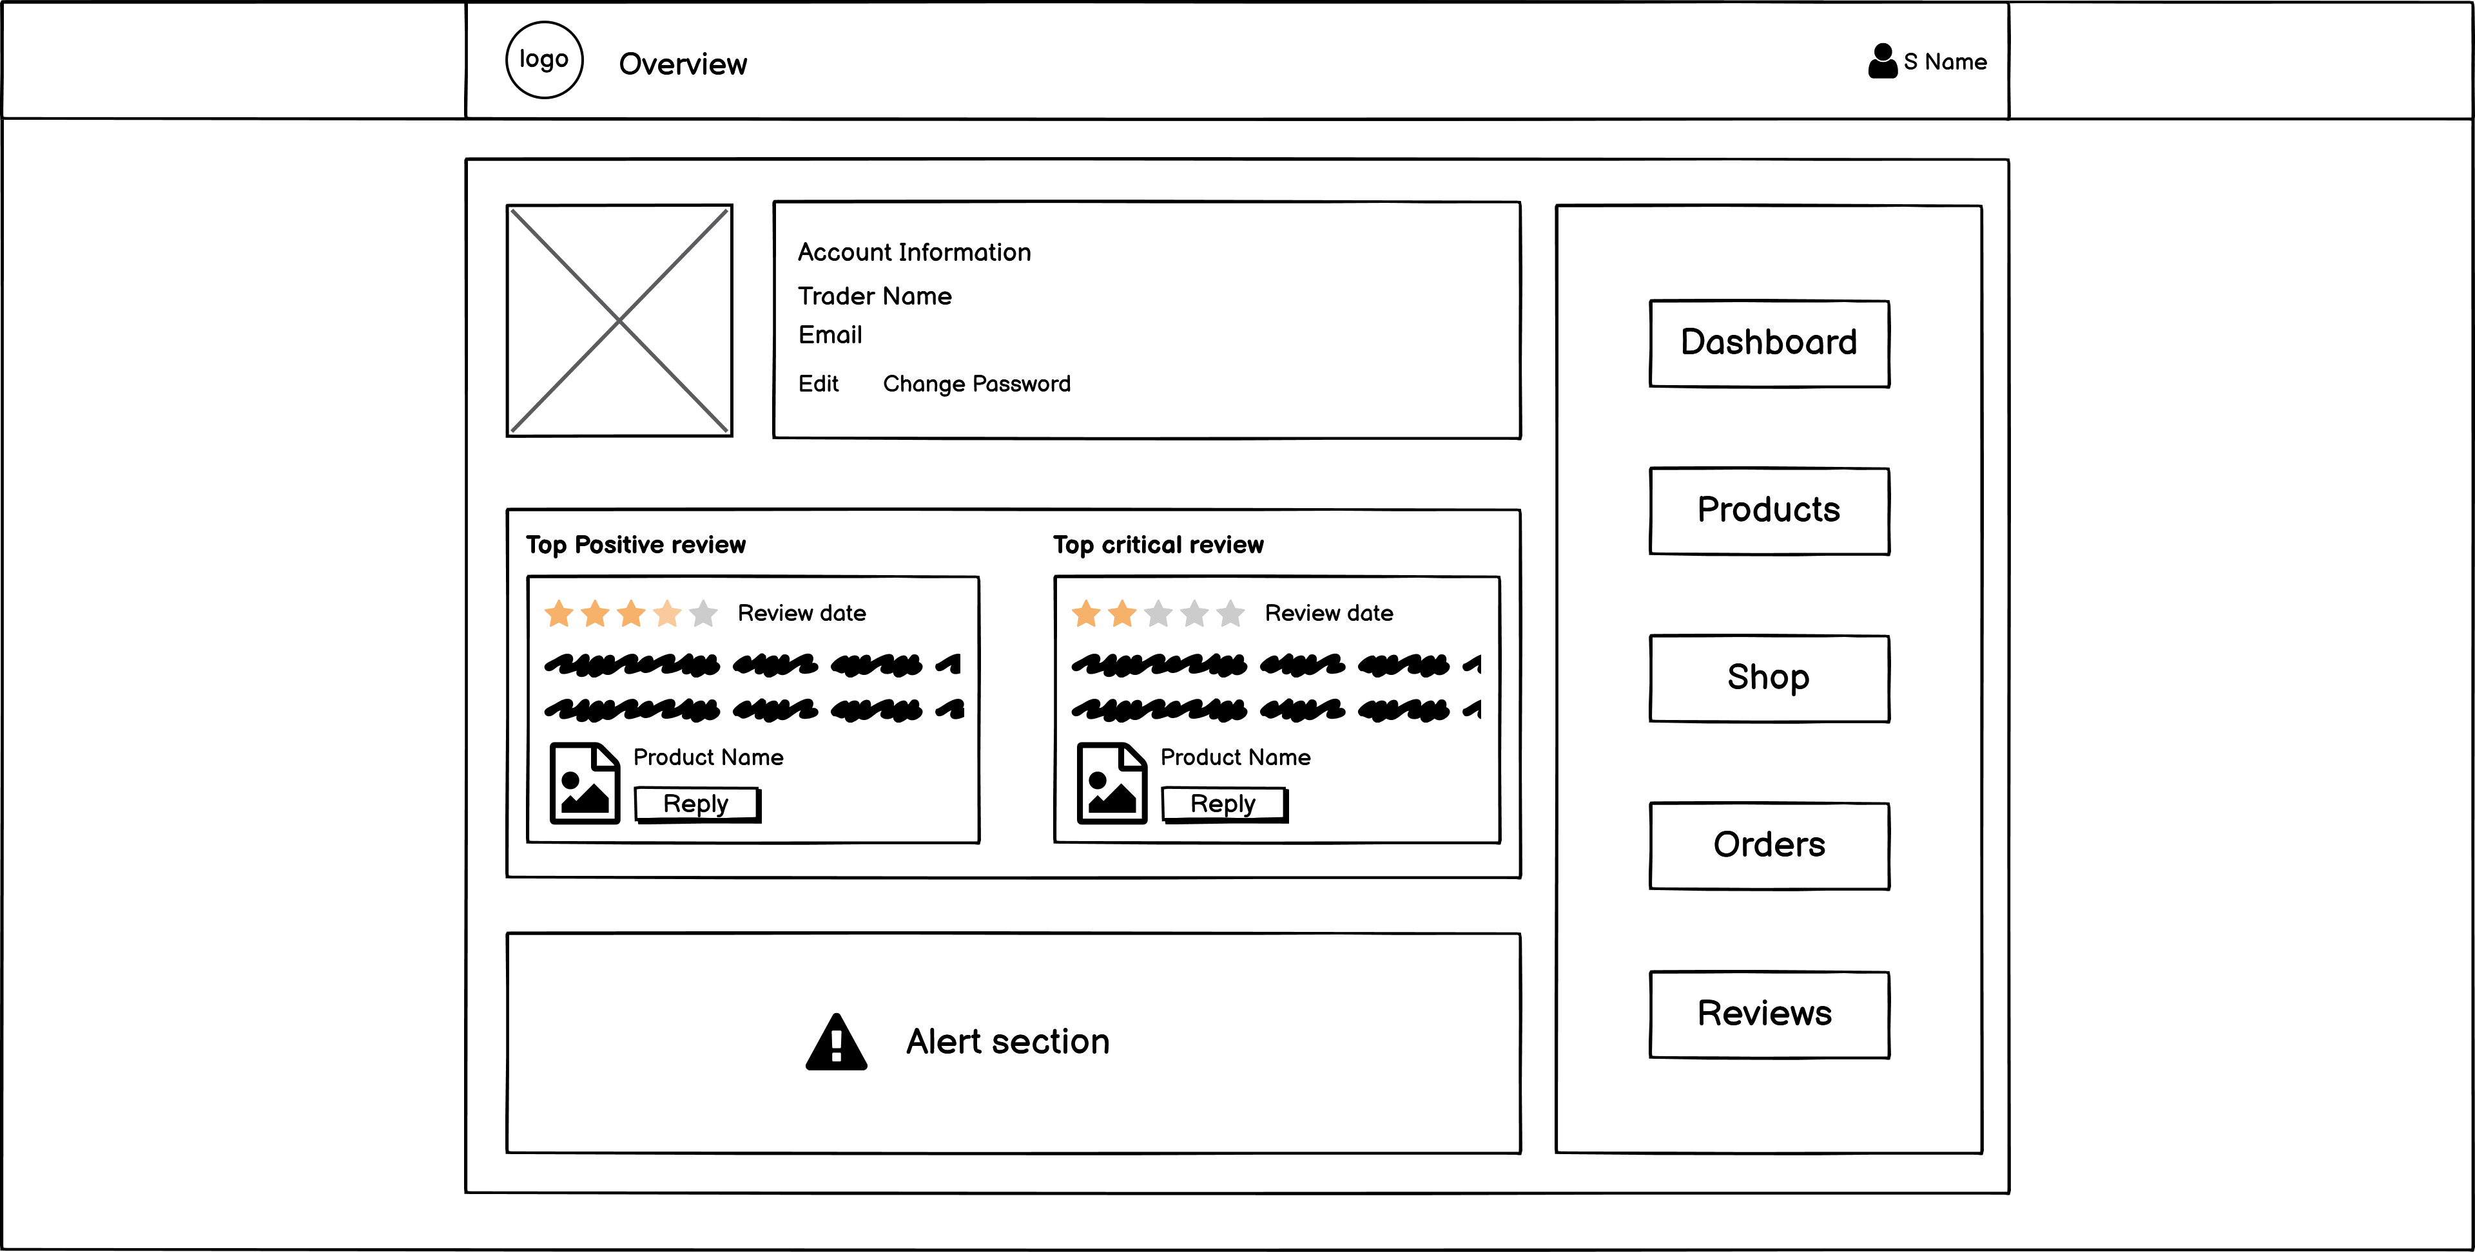

Trader orders

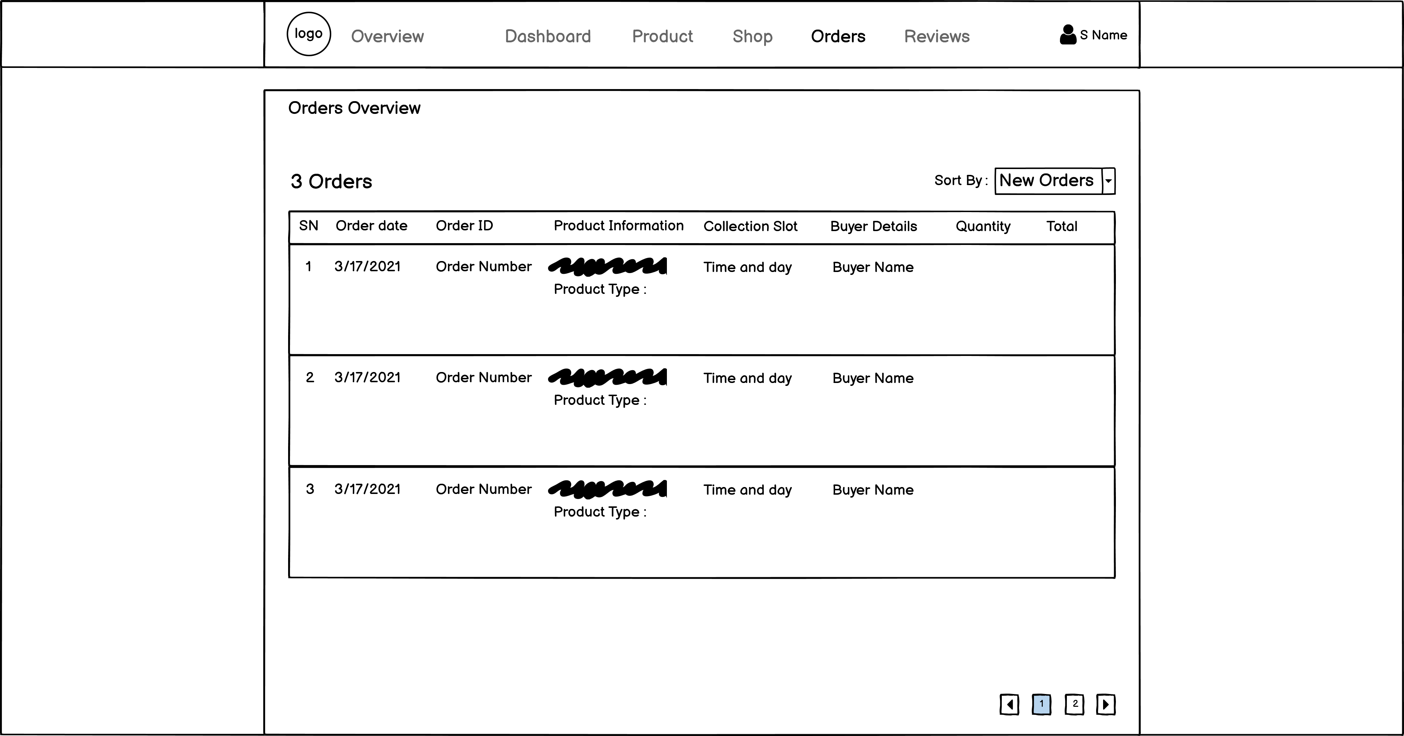

Trader Product CRUD

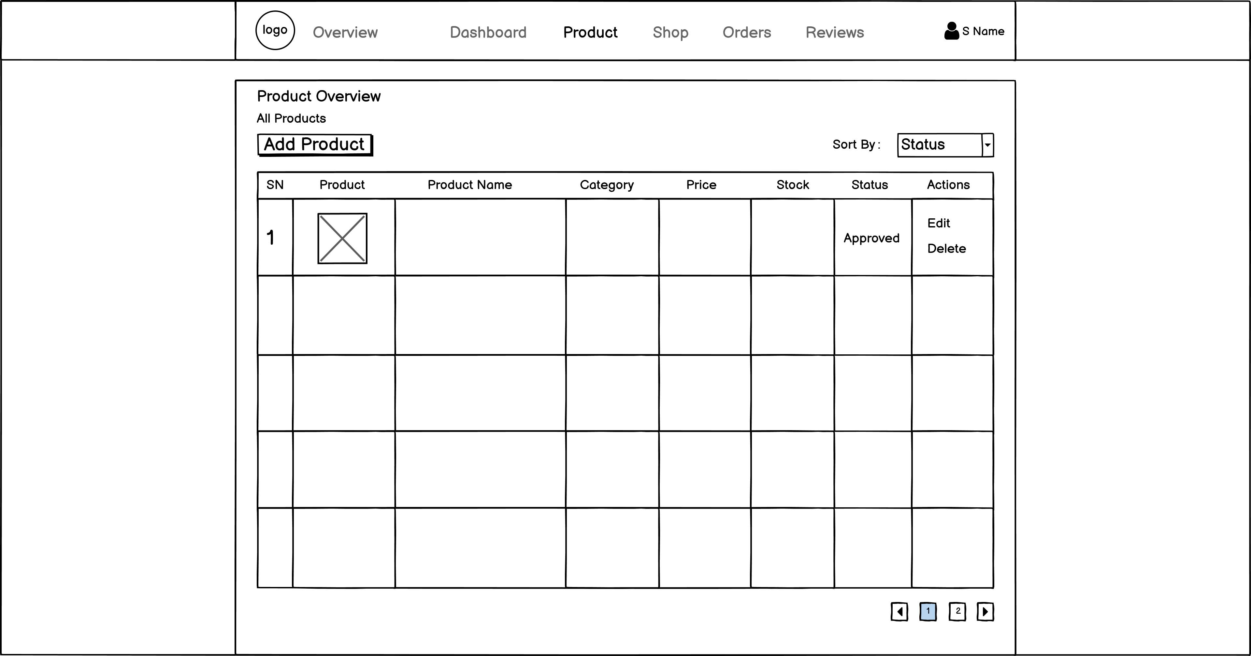

Trader review

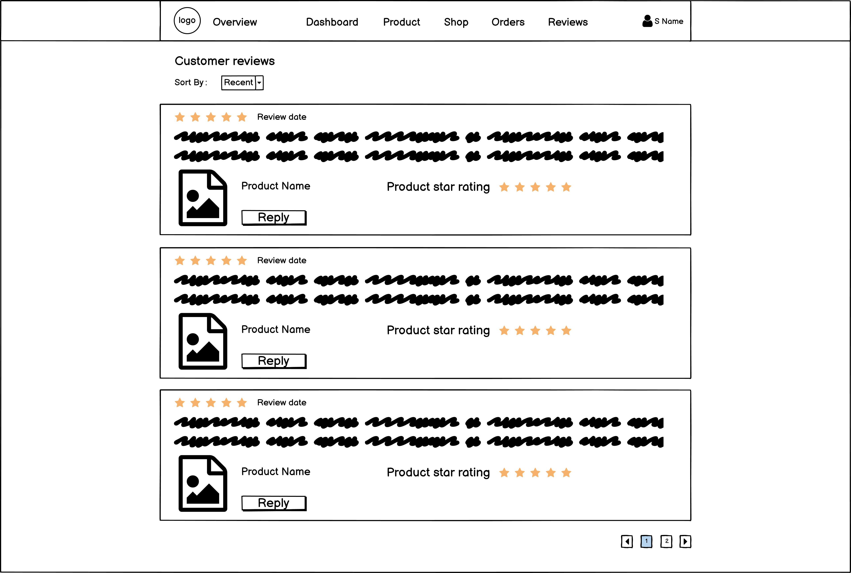

Trader Shop

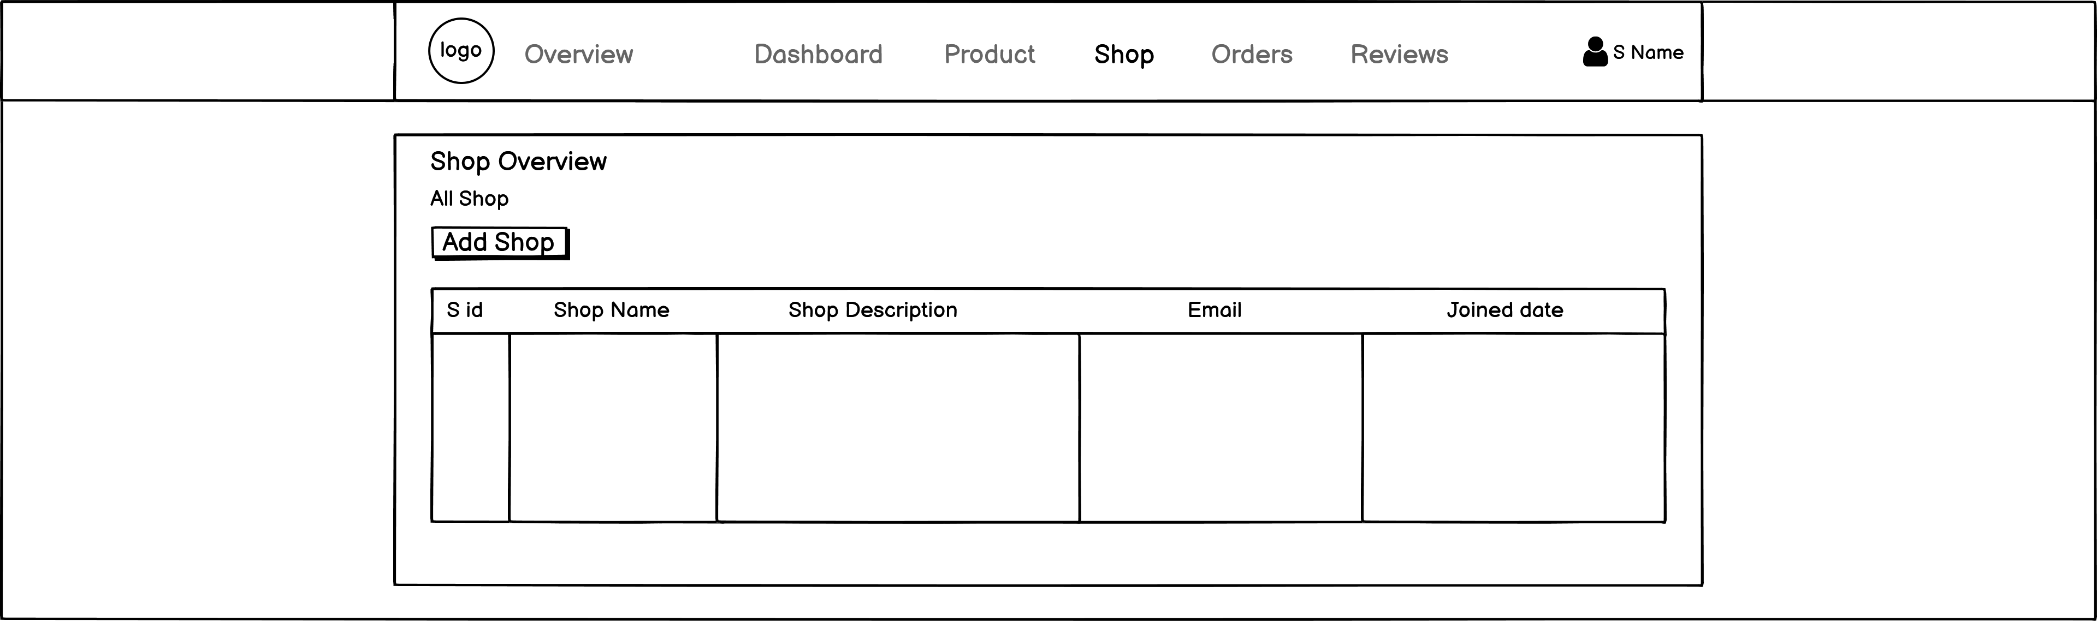

About Us

